User Interface Customization

This section contains information related to customizing the Windchill user interface.

User Interface Technology Overview

This chapter explains and gives some basic overview of the Windchill Client Architecture UI Framework.

Before reading this chapter, you should be familiar with Java, JavaServer Pages (JSP), JavaServer Pages Standard Tag Library (JSTL) and Expression Language (EL).

Windchill Client Architecture Overview

The Windchill Client Architecture provides a framework for building pages easily and consistently by providing a standard set of components and services that are configurable and customizable. The set of components includes, but is not limited to, a table, a tree, an information page, a wizard, and a dynamic javascript menu. At a lower level, these container components use other common components, called actions, action models and GUI components, to display data inside of them.
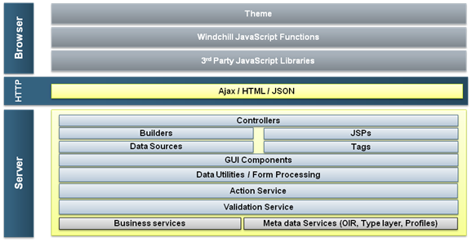
The Windchill Client Architecture is Model-View-Controller based. There are two MVC based paths available for use, a Java Builder based approach and a JSP based approach.

Java Builder based
This approach is the recommended way of implementing tables, trees, information pages, and panels of attributes since Windchill release 10.0. When implementing one of these components, the configuration of the component is specified in a ComponentConfigBuilder (java file) and the data acquisition is specified in a ComponentDataBuilder (java file).

JSP and Tags based

This approach was used in previous releases and should only be used for implementing wizards (create/edit) and property panels.

Although tables and trees can be implemented with this approach it is not recommended.

When implementing one of these components, the configuration of the component and the data acquisition is defined in a tag (from Windchill Components tag library) in a JSP.

Please note that at some point in the future, this approach will be deprecated in Windchill.

The future vision is to have all components in the system converted to use the new Java model and controller builders.

When creating new customizations use the Java Builders path when possible. Many previous customizations using the Tag and TagLibs path will continue to work.

URL Strategy

In a Windchill client application starting at 10.0 the URL consists of multiple pieces. The URL still begins with the host information and the Windchill web app name. Then the URL has the following components.

app/ | app/ is the address of the shell. The shell renders the header, navigator and a blank content area.
# | The # character is the token. The complete 10.0 URL is actually made up of two URLs put together. This token marks the end of the URL for the shell and the beginning of the URL for the content that will be displayed within the content area.
ptc1/comp/  ptc1/tcomp/  ptc1/ | After the # token is the URL to the content page. It is loaded via AJAX into the content area. This is a logical content address, not a physical location. The URL after the # token is normally an MVC path to a controller, for example: ptc1/comp/recent.updates.table  The URL after the # token can also take the form ptc1/<objecttype>/<action name>, which mirrors the action mappings in actions.xml, for example: ptc1/report/listUpdates
  comp | Used in the URL to specify that the builder to look up is not type based.
  tcomp | Used in the URL to specify that the builder to look up is type-based.
Query Strings | After the question mark is the query-string as in any other URL. It is possible to have two query strings in the URL. When the ? is before the # token the query string parameters will be passed to the shell. When the query string is after the content address after the # token the parameters will be passed to the page in the content area.

Most pages need to be loaded through the shell to work correctly. Calling their URL’s directly will load them without the CSS and JavaScript they need to function correctly. Every page in Windchill is now being served through a controller class. Even URLs which look like direct JSPs are being served through the LegacyController. Spring MVC is used under the covers to configure them.

Java Builders

This approach presents several advantages over the older JSP and Tags based approach. By separating the model and controller from the JSP, we enable a more flexible and maintainable system.

For example, several different JSPs can now take advantage of the same java builder. And, because, builders are now written in java, they can share attributes through inheritance.

The basic steps to produce many components (table, tree, attribute panel, etc) are:
• Describe the component (Component Config Builder)
• Acquire the necessary data (Component Data Builder)
• Render the component (JSP)

Controller – ComponentController
Requests for JCA components are routed to a centralized ComponentController. This controller derives the component ID from the request parameters, and then uses Spring configuration to look up builder implementations.

Model – Component Config and Data Builders

The model for your UI is made up of the component configuration information and the data.

These are created by a class or classes that implement the ComponentConfigBuilder and ComponentDataBuilder interfaces.

• ComponentConfigBuilder

You control the rendering of your UI through a Java Class that implements the ComponentConfigBuilder Interface. This interface contains one method buildComponentConfig. This method should contain all the configuration information needed for the UI you are building. One example of a ComponentConfigBuilder might look like the following:

public ComponentConfig buildComponentConfig(ComponentParams params) throws WTException {
ComponentConfigFactory factory = getComponentConfigFactory();
TableConfig table = factory.newTableConfig();
table.setLabel("My Table");
table.setSelectable(true);
table.setType("wt.pdmlink.PDMLinkProduct");
table.setActionModel("my_toolbar_actions");
table.setShowCustomViewLink(true);
table.addComponent(factory.newColumnConfig(ICON, true));
table.addComponent(factory.newColumnConfig(NAME, true);
table.addComponent(factory.newColumnConfig(INFO_ACTION, false));
return table;
}

• ComponentDataBuilder

The data for your UI is created by a Java Class that implements the ComponentDataBuilder Interface. This interface contains one method buildComponentData. The object returned from this method should represent the Model for the UI and can take multiple forms. Some examples of what this method might return are ComponentData, a Persistable, a QuerySpec, any custom Java Object, etc. One example of a ComponentDataBuilder might look like the following:

public Object buildComponentData(ComponentConfig config,
ComponentParams params)
throws Exception {
String tableId="netmarkets.product.list";
return ProductListCommand.getProducts(tableId);
}

• Data Sources
Table and Tree components are able to make use of a new feature called DataSources. DataSources provide improved perceived table and tree performance through features like the ability to asynchronously load data and the ability to sort and scroll data on the client. To make use of this new asynchronous feature, your Component Data Builder should implement ComponentDataBuilderAsync for table components and TreeDataBuilderAsync for Tree components.

View — JSP

In this approach, the JSP is simply a “view”, rather than a combination of all three, as it is in the JSP and Tags approach. Each component has a default view (JSP) to render out the component, however if you wish to override the default view you can call the setView() on the ComponentConfig that your ComponentConfigBuilder returns. All the view jsps should be located in codebase\WEB-INF\jsp base location.

• Basic Elements of the JSP
When Creating a JSP view for a Java Builder, you will need to be aware of a few important jsp fragment files. The first and most important is the begin_comp.jspf. This files exists in codebase/netmarkets/jsp/util/. The purpose of this jspf is to setup the model data information required by the view.
Another jspf that is included is the end_comp.jspf also located in codebase/netmarkets/jsp/util/. The purpose of this file is to: Mark that the page load is complete to allow proper functioning of the javascript within the page. An example of a jsp view might look like:
<%@ taglib uri="http://www.ptc.com/windchill/taglib/jcaMvc" prefix="mvc"%>
<%@include file="/netmarkets/jsp/util/begin_comp.jspf"%>
<mvc:table setPageTitle="true"/>
<%@ include file="/netmarkets/jsp/util/end_comp.jspf"%>

Supported Components
• Table
• Tree
• Information Page
• Attribute Panel
• Attribute Table
• Property Panel

JSP and Tags

Several tags and taglibs are delivered as part of the framework. These taglibs contain a set of handlers for including components and other common functionality into your pages. The basic steps to produce many components (table, tree, property panel, wizard, etc.) are:
• Describe the component (JSP)
• Acquire the necessary data (Data Acquisition Tags)
• Render the component (Component Renderer Tags)
The configuration of these phases is done by calling the tag handlers in the JSP Page. To use the tags, you need to include the components library. The following code snippet includes the library:
<%@ taglib uri="http://www.ptc.com/windchill/taglib/components" prefix="jca"%>

Controller — JSP

• Basic Elements of the JSP
You will need to be aware of a few important jsp fragment files. The first and most important is the begin.jspf. This files exists in codebase/netmarkets/jsp/util/. The purpose of this jspf is to:
◦ Include a tag for rendering the shell that surrounds all pages.
◦ Take care of housekeeping like:
▪ Instantiates the beans (context, clipboard, etc)
▪ Executes a command (for actions only)
▪ Includes some JS functions
▪ Creates ONE form for the page data (called mainform)
▪ Provides support for closing pop ups and refreshing the main page
Another jspf that is included is the end.jspf also located in codebase/netmarkets/jsp/util/. The purpose of this file is:
◦ mark the begin and end of the content area for DHTML content switching
◦ catch exceptions and handles them if they occur within the page/
When constructing a wizard, there is a special beginWizard.jspf file, locatedin netmarkets\jsp\components, that should be used instead of the begin.jspf that will do essentially the same things as the begin.jspf.

• Component Description Tags

Component description tags are the first tag included in the jsp. These generally take the form of describe*Tag. (E.g. DescribeTableTag)

Component Description Tags define the columns/properties that the component will display. This happens first in a JSP since the way the data is retrieved may depend on the properties that are requested.

During the component description phase the developer uses a “describe” tag handler that tells the infrastructure about the component they would like to display. One example describe handler is the describeTable, which might look like the following:

<jca:describeTable var="tableDescriptor" id="my.table.id" configurable="true"
type="com.myco.MyType" label="${myLabel}">
<jca:setComponentProperty key="actionModel" value="my action model"/>
<jca:describeColumn id="name"/>
<jca:describeColumn id="nmActions" />
<jca:describeColumn id="status">
<jca:setComponentProperty key="percent" value="true"/>
</jca:describeColumn>
</jca:describeTable>

Structure of the example
The tag contains a set of nested tags which give it some structure. There are two kinds of nested tags:

◦ setComponentProperty

This tag configures the properties of its parent tag that aren’t exposed as attributes of the parent tag itself. This gives the infrastructure and the developer some flexibility about the metadata they’d like to be available down the road, without always requiring a tag library definition (tld) update to do so.

◦ describeColumn

This tag describes a particular column that the developer wants to display. Like the parent describeTable tag, this tag accepts child setComponentProperty tags. There is also a describeProperty tag that has the same semantics when used in property panels.

Underneath the covers, the describeTable tag is simply configuring a java bean that implements the ComponentDescriptor interface. The attributes that are available via the tag handler typically correspond to properties of the ComponentDescriptor. The ComponentDescriptor object is important to keep in mind as it comes into play later on during the data acquisition phase.

The ComponentDescriptor object that the describe tag handlers build is communicated to the rest of the world via the required "var" attribute. The handler creates a scoped variable for the ComponentDescriptor object named whatever the var attribute value is.

In the example above, the var attribute was mapped to "tableDescriptor", but it can be mapped to any legal JSP variable identifier. Note that this semantic for the var attribute is reused from the JSTL tag handlers. Since the ComponentDescriptor object is a scoped attribute, it can be referenced later in the page using the JSP EL as well as Java code. Subsequent tags can now refer to the descriptor using the ${varName} syntax, for example.

Model — Data Acquisition Tags
The necessary model data is acquired through data acquisition tags. These generally take the form of get*Tag. (E.g. getModelTag)

The Data Acquisition Tag will be the second phase and will come second in your jsp. This is because the Data Acquisition Tag gets the model data based on the description from Component Description Tag.

In the data acquisition phase, the developer combines a component description with some additional information on how to actually go and get the data that will back the component.

One example of getting a model for a table might look like the following:

<jca:getModel var="tableModel" descriptor="${tableDescriptor}"
serviceName="com.myco.MyService"
methodName="getMyObjects">
<jca:addServiceArgument value="${myArgument}" type="java.lang.Long"/>
</jca:getModel>

Structure of the example

• descriptor and var
The tag gets a component description by using the EL to look up the scoped "tableDescriptor" variable. The tableDescriptor variable would typically be put in the page by a previous describe tag that had a var value of "tableDescriptor".
Like the describe tags, the get tags produce a java bean that is added to the page as a scoped variable named with the var attribute value. In the case of the get tags, the resulting bean is an instance of ComponentModel.

• What is it doing?
Developers typically don't interact with the ComponentModel object produced by the get tags. Instead, the developer provides information on some lower-level API that the client infrastructure invokes and then transforms into a ComponentModel. The sample code above, for example, will invoke the com.myco.MyService.getMyObjects(myArgument) method, take the results, and turn these into a ComponentModel object.

View — Component Renderer Tags
The view is rendered by the Component Renderer Tag. These generally take the form of render*Tag (E.g. RenderTableTag)
This produces HTML and JavaScript based on the model data. Rendering using Component Renderer Tags is usually simple for the developer to set up. The Windchill Client Architecture provides a few render tags that take the ComponentModel produced by a “get” tag and turns it into HTML and JavaScript. Like the get tags, these tags uses the EL to accept scoped variable data from the page:
<jca:renderTable model="${tableModel}"/>

Structure of the example
In this case, the table renderer is taking an input ComponentModel assigned to the scoped variable "tableModel", and rendering it as a table.

Supported Components
• Wizard (Create/Edit)
• Table
• Tree
• Property Panel
• Attribute Table

Additional Resources
• Tag Library Documentation
The Windchill Tag Library Documentation is delivered with the product and can be accessed through the UI. To locate the documentation, first enable the customization examples and tools, then browse to the customization navigation and select the tools option.
Under the API documentation section of the page you will find a link to the Windchill Tag Library Documentation

Common Java Services

GUI Components
GUI Components are objects that define how an attribute is to be rendered. They are controlled though properties set in the Data Utilities. A GUI Component also contains a renderer that is responsible for writing out the HTML and/or JavaScript.

Data Utilities
Data Utilities are delegates invoked during construction of the model that allow post-processing and/or augmentation of the data returned by data acquisition APIs

Action Service
Configuration of actions and action models that are available within the system are defined using xml files. There is an action service that reads these xml files and manages the set of actions and action models. Interaction with the service is done via the components. Developers in general would not call the service directly.

Validation Service

Validation of actions and properties can be done via logic encapsulated into a validator that gets executed when a component such as a action menu, table, or property panel includes that action or property.

Validation of actions and properties can be done via logic encapsulated into a validator that gets executed when a component such as a action menu, table, or property panel includes that action or property.

The service will invoke the appropriate delegates to gather the requested status for that action or property. As a customization point, you can write a delegate that is mapped to a specific property or action, that contains logic to indicate when that element is valid to show, hide, or disable in the user interface.

The validation framework is tied into the Role Based UI framework Role based support is included for most actions in the product, and customized actions can also take advantage of this capability. Role based capability is supported for reusable attributes created via Type and Attribute Management utility, not modeled attributes.

That validation service will actually call the role based service as a first pass of validation. If the action or property is valid for the user based on role, the service will then invoke the appropriate delegate.

Additional Resources

Theme
The Windchill theme defines the look and feel (colors, fonts, images etc). These are controlled by css.

Windchill Javascript Functions
The Windchill JSDoc Javascript documentation is delivered with the product and can be accessed through the UI. This documentation describes common JavaScript functions which are available for use in your customizations. To locate the documentation, first enable the customization examples and tools, then browse to the customization navigation and select the tools option.

Third Party Javascript Libraries

While PTC does use some 3rd party JavaScript libraries, all supported customizations use PTC’s own APIs. It is recommended that customizers use these supported APIs when possible. These underlying libraries may change without notice, which may negatively affect any customizations. If it is not possible to avoid using 3rd party library API’s, it is the customizer’s responsibility to acquire appropriate development licenses, and assume maintenance responsibilities for those usages going forward.

For example, although the EXT component library has been used to create Windchill and is therefore available to you in your customization environment, if you build any customizations that directly reference EXT apis (found in the EXT namespace) you will be required to purchase EXT licenses for your customizations. If you only reference APIs in the PTC namespace you will not need any EXT license.

Javadoc

The Windchill Javadoc is delivered with the product and can be accessed through the UI. To locate the documentation, first enable the customization examples and tools, then browse to the customization navigation and select the tools option.

Java Beans

There is a set of Java Beans that is part of the framework that carries data like context and session information. The developer does not need to interact with most of the beans.

Enabling Customization Examples and Tools

To enable the customization examples and tools icon in the Navigator you must set a site preference.

- Login as the Site Administrator and navigate to Site > Utilities.
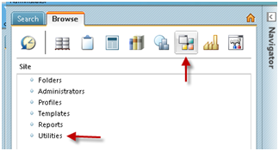
- In the Utilities List Select the Preference Manager. Expand Client Customization.
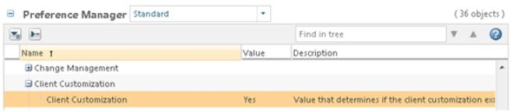

- Right click on the Client Customization Preference and select Set Preference and set the preference to “Yes.” Now you will see the customization icon in the Navigator.
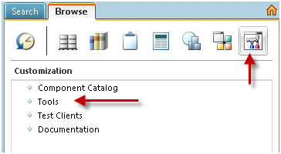

Windchill Client Architecture Common Objects Overview

This section provides a basic overview of common Windchill Client Architecture objects used in the UI.
These objects will be heavily used in customizations but are not likely to be extended except for NmSimpleOid.

NmCommandBean

NmCommandBean provides Windchill Client Architecture state information to other Windchill Client Architecture layers. It is the what, where, and how of the UI. It wraps the request object and adds value by parsing the parameters into related items.

Once initialized by the request, the NmCommandbean can answer Windchill Client Architecture related questions. It essentially carries the request and helper methods to access the jca state information.
Interesting attributes:
• Context: the where compcontext, parentContext, element context, etc are used to determine what page is displayed and where actions are launched. (Note that this is becoming obsolete and should be deprecated in the next release.)
• oids : the objects that actions or pages apply to.

Contains a number of helper APIs:
• getActionOid() : gets the object that is the target of the action.
• getPageOid(): gets object that the page is being displayed in this page.
• getViewingContainer() : gets the container that the page is displayed in.

NmAction
NmAction represents a line from actions.xml which describes a page in Windchill. It is rendered as all the icons and links that one can click to make changes to the Windchill system. Each jsp page should be described by an NmAction in an xml file. The localized attributes of the NmAction can be found in the action.properties or other rbInfo files.

NmOid
A Netmarkets version of a WTReference that hides some details of the different reference types and provides helper apis to aid in caching. Furthermore, it is the object that understands how to parse any string format from the request that represents an object in the db.

NmSimpleOid
NmSimpleOid represents a non-persisted business object. It is often to represent some item that has not been created yet or some object that wraps a persistable with more information. String parsing of the NmSimpleOid is completely handled by the code for the relevant table and actions and should be in an NmObjectUtility.

NmContext
NmContext represents a UI address of a page. (Note that this is becoming obsolete and should be deprecated in the next release.)
• Component is a jsp page
• Jsp page can include multiple components
• Component address includes addresses of ancestor components
• Context (address) of a component B is “Address 1 - Address B”

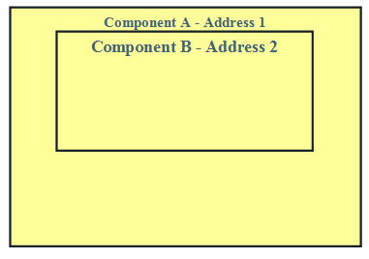

Javascript Functions Overview

This section explains some of the common Windchill Client Architecture javascript functions.
These functions are located in: <Windchill>\codebase\netmarkets\javascript\util\main.js

TableUtils — package

Name | Purpose
getTableRows (parentNode) | Return array of Nmcontexts for each row in a table given the outer DIV DOM node.
getTableRowsByID (tableID) | Return array of Nmcontexts for each row in a table given a table id
getTreeRows (parentNode) | Return array of Nmcontexts for each row in a table given the outer DIV DOM node.
findTableID (node) | Given some DOM Element, walk up the DOM tree to figure out which table this is in.
findParentTableNodeId (node) | Given some DOM Element, walk up the DOM tree to find the table DOM Node.
getAddedRows (tableid) | Gets the hidden input field that contains the added rows of a table id. Returns String that can be tokenized.
getRemovedRows (tableid) | Gets the hidden input field that contains the removed rows of a table id. Returns String that can be tokenized
getParentTR (node) | Walk up the Dom tree finding the first <tr> tag
removeParentRow (oid, node, tableid) | Remove a row from a table/tree
isTableCheckBox (node) | returns true/false if the dom NODE is a row in the table with the class JCA_tablerow  @param node - checkbox dom node
deSelectOtherTableRows (table id) | Invoked when a checkbox is clicked and it changes the row css so that it appears as highlighted.
getFormNodes (node) | Get all the form nodes within the given parent node. If parentNode is unspecified, the entire document is searched.
disableRow (tr) | Disable all form inputs in the given row
updateHeader (tableid) | Updates row Count in Title bar.
getUnformattedTableId (tableid) | turns the outer div node id into a normal table id defined by the jsp tags table__jca.sometable__TABLE -> jca.sometable
getFormattedTableId (id) | turns a div table id into the simple table id used as in the jsp tags  table__jca.sometable__TABLE -> jca.sometable
updateFooterCount (tableid, count, changeValue) | Updates Count of selected rows in footer.
disableSelectAllChBox | Disables the select all checbox given a table id
enableSelectAllChBox | enables the select all checbox given a table id

TreeHandler

Name | Purpose
toggle (…) | The expand/Collapse function, Finds the current state of the row and changes it to the opposite. This may result in refreshing the page for legacy trees otherwise an ajax call is made to get new rows for the expand action.
collapseFolders (oid, action, list) | Will collapse a row or expand the folder row by changing its icon.  Param alist is a list of tree rows, if null it will be calculated from the page. It is faster to not lookup the list of tr nodes over and over.  Param action - 'c' or 'e' for the action type

asyncResponseHandler

Name | Purpose
handleResponse (responseText, responseObject) | Parses actions from an asynchronous response. Generic high level method that will delegate to all the types of responses.
stripText (text,  divID,  skipScriptEval,  start,  end) | Gets rid of unwanted text from the response. Substrings out antying not inbetween the html comment.  Can execute javascript blocks conditionally.  Start/end are the html comment strings to use to find the response in.

rowHandler

Name | Purpose
addRows (oidList,  table_id,  tableRows,  params) | Add rows to a table.  oidList is an array of oids to add as rows.  Tablerows is an array of all current rows to improve performance of the api  Params is extra params to add to the ajax request.
removeRowsFromParentTable
removeRows ( rows, table_id, visually_remove ) | Remove rows from the table, rows is an array of oids.

requestHandler

Name | Purpose
handleRequest (table_id, params) | Refreshes a table given the params
doRequest (url, options) | Make the ajax request for the table. Used by the above method to change the url with the options set.

Other Functions in main.js

Name | Purpose
getElementsByClassNameAndTag (className, parentElement , tag name) | Returns all the children of the parentElement that match the given Tagname and contain the className. Optimized version of getElementsByClassname so that it does not have to look at all the items in the page.
refreshDivTag(id, name, url) | Refreshes the contents of a div (via Ajax) when an element fires its change event.
getElementHtml(params, divID, doAsynch, url, doFade, successFunc, failFunc, options) | Used to create a fade effect on a portion of the html page that is being updated via an ajax request.
addRows( list, tableId, refresh, doAjaxUpdate, preventDuplicates ) | Modifies the hidden form fields of tables used in wizards when users dynamically add rows to said table. Can cause the row to be added dynamically if the doAjaxUpdate is true.
PJLrefreshOpener() and refreshOpenerOnly() | Refreshes the parent window.
getClipboardItems() | Family of methods for getting contents of the Clipboard as a comma delimited list.

Wizard.js functions

Name | Purpose
handleRequest (table_id,  params) | Refreshes a table given the params
doRequest (url, options) | Make the ajax request for the table. Used by the above method to change the url with the options set.
parseAnonymousParams (startIndex, params, result) | Add request params to the options based on the params list passed in.
getParamString | Adds all this form params to the ajax request including the params passed in.
updateStepImage | Updates the wizard step indicator images for all steps based on the current state.
updateEmbeddedText | Updates the embedded help based on the current step.
getNextStep | Gets the next step id.
setNextStepDirty | Sets the next step in the wizard to be refreshed when displayed
goBack | Make the wizard go back one step
goNext | Make the wizard go to the next step
setActiveStep (stepId, wizardAction) | Makes a specific step active.  wizardAction is an optional parameter. It indicates if the user is attempting to go back or forward in the wizard.
findStepIndex | Find the index of a step id
setNextStep | Override what the next step id is
setStepDirty | Set a step to need a refresh should it display again
setStepClean | Set a step to NOT need a refresh should it display again
setStepIncomplete | Set a step to need to be vistited again as it needs more info
setStepComplete | Set a step to NOT need to be vistited again as it does not needs more info
setStepRequired | Make a user visit a step before the wizard can be completed
setStepOptional | Make a user able to complete the wizard WITHOUT visiting the specified step id
removeStep | Remove a step from the list of steps
insertStep | Add a new step to the list of steps based on what has already happened - dynamic steps
resetOkButton | Sets the ok button to be displayed or not based on the current state.
resetNextBackButton | Sets the next/back button to be displayed or not based on the current state.
disableOkButton | Force the finish and apply buttons to be disabled
enableOkButton | Force the finish and apply buttons to be enabled
getCurrentStep | Gets the current active step id
refreshCurrentStep | Refreshes the current wizard step
refreshStep | Refreshes the speicified wizard step
getAbsoluteUrl | This function takes a url and turns it into an absolute URL.
goProgress | Turns on the progress indicator
stopProgress | Turns off the progress indicator
onSubmitMain | Finish the wizard by executing it on the server
handleSubmitResult | Handles the response of the wizard submission, the response is mostly a form result string object that tells the browser what to do. Not quite jSON yet though.
onClickValidation (evt, key) | To do Ajax validation when an action is clicked.  The event object.  The key to use in validation code
checkRequired (skipErrorMsg) | Grabs every input that is styled as 'required' and checks to make sure it has a value. If any required fields do not have values, the field in question is highlighted and an alert message is displayed. This function returns a boolean that is true if the required fields are entered and false if any required field is not filled in.  @param skipErrorMsg can be used to suppress the alert message

Adding Custom Code to all Windchill Client Architecture Pages

This section explains how to add custom code to all Windchill Client Architecture pages.

Javascript files

To add any custom javascript to all the pages, you should create a new custom jsfrag file. The file needs to be deployed in: codebase\netmarkets\javascript\util\jsfrags

The file can be named custom.jsfrag or any other name that is not already in use.

To include the file in all pages run the combine command. This will make the js available in main.js: Windchill/bin>ant -f jsfrag_combine.xml

CSS Files

To add any custom css scripts to all the pages, modify the netmarkets.presentation.cssFiles property in site.xconf to have the necessary css files included. You can include multiple css files as a comma or semicolon separated list in the value. Note that order is important, and that the files will be loaded after the Windchill style sheets so they will properly override the default styles.
<Property name=" netmarkets.presentation.cssFiles"
overridable="true"
targetFile="codebase/presentation.properties"
value="mypath/mycss.css;mypath/mycss2.css"/>

Customizing the Theme

It is not recommended to change any of the standard Windchill CSS style sheets. Instead, insert custom stylesheet files using the as described above. To discover which styles are defined, a good place to start is the theme file: codebase/netmarkets/themes/windchill/xtheme-windchill.css

Maintenance Messaging

The file codebase/netmarkets/jsp/util/begin_custom.jspf can also be used to add custom messages to the page for system maintenance or mass communication. For example, place the following code in this file:
<div style="color: sienna; position: absolute; top: 15px; z-index: 1000; left: 300px; font-size: 18px;">
<h1>This is a test</h1></div>
</div>

You should place any HTML for your message within a div as in this example. You can then use css to position and style the message as desired.

Character Encoding Considerations

On recent versions of Tomcat the following line should be added to begin_custom.jspf to ensure that the character set is set to UTF-8. Otherwise content may not display correctly.
<%@ page contentType="text/html; charset=UTF-8" %>

Color Customizations in the Reference Designator Differences Column

The values for the reference designator differences column can be displayed with custom css which gives the customizer the ability to display these values in any color they want.
1. Use a new or existing custom css file.
2. Create a custom css for the reference designator differences plus values. The following example will display the values as green:
span.dsb-reference-designator-diffs-plus-value
{
color: #53bc3c;
}
3. Create a custom css for the reference designator differences minus values. The following example will display the values as red:
span.dsb-reference-designator-diffs-minus-value
{
color: #FF0000;
}
Customization Points
codebase/netmarkets/jsp/util/begin_custom.jspf

MVC Components

This section contains an overview of MVC components as well as where to find information on MVC tables.

MVC Components Overview

This explains and introduces the different pieces of the Windchill Client Architecture UI Framework.
• MVC
• Data Sources
• JCA Components

MVC

Model–View–Controller (MVC). Model represents enterprise data and the business rules that govern access to and updates of this data. View renders the model. Controller translates interactions with the view into actions to be performed by the model.

For web-based clients such as browsers uses Java Server Pages (JSP ) to render the view, Servlet as the controller, and Enterprise JavaBeans (EJB ) components as the model.

MVC in Windchill

In Windchill 9.x, for JCA Clients, JSP was serving both as the Controller and View. In Windchill 10.0, we are introducing a clear separation between Controller and View for which we are using Spring MVC Framework.

The MVC pattern improves the maintainability and testability of our implementations.

Having multiple servlets as controllers is going to be difficult to manage and hence we have adopted the Front Controller pattern approach – a main servlet to make the control more manageable. DispatcherServlet acts as the Front controller.

Request Handling
The servlet and servlet mapping for the Web container is defined in <Windchill>\codebase\WEB-INF\web.xml. The below mentioned url patterns are mapped to Spring DispatcherServlet and hence will be termed as MVC requests.
<servlet-mapping>
<servlet-name>MVCDispatcher</servlet-name>
<url-pattern>/servlet/WizardServlet/*</url-pattern>
<url-pattern>/servlet/ActionsMenu/*</url-pattern>
<url-pattern>/servlet/RecentList/*</url-pattern>
<url-pattern>/servlet/Navigation/*</url-pattern>
<url-pattern>/servlet/SuggestServlet/*</url-pattern>
<url-pattern>/servlet/TypeBasedIncludeServlet/*</url-pattern>
<url-pattern>/servlet/UIValidationAJAXServlet/*</url-pattern>
<url-pattern>/ptc1/*</url-pattern>
<url-pattern>/app/*</url-pattern>
<url-pattern>/gwt/*</url-pattern><servlet-mapping>
</servlet-mapping>
<servlet>
<description>MVC Dispatcher Servlet for JCA</description>
<servlet-name>MVCDispatcher</servlet-name>
<servlet-class>org.springframework.web.servlet.
DispatcherServlet</servlet-class>
<load-on-startup>1</load-on-startup>
</servlet>

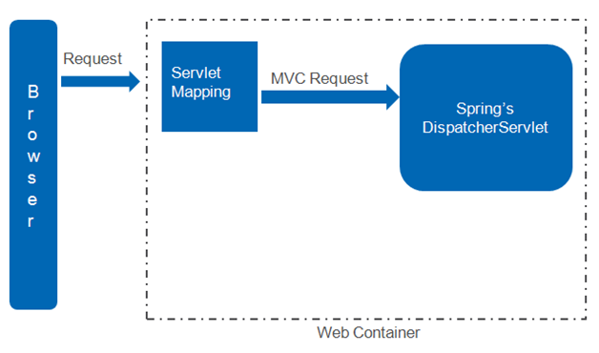

The web container, based on the servlet mapping configured, directs all the MVC Requests to Spring DispatcherServlet.

Application Context
An application Context represents the set of configuration files that are used to provide configuration information to the application and is in <Windchill>\codebase\WEB-INF\MVCDispatcher-servlet.xml.
• Imports all the Spring configuration xml files that reside at <Windchill>\codebase\config\mvc\ folder. Any custom configurations should go in <Windchill>\codebase\config\mvc\custom.xml.
• Defines the handler mapping by loading the mappings specified in the properties files at <Windchill>\codebase\config\mvc\. Any custom handler mapping should go in <Windchill>\codebase\config\mvc\custom.properties.
When the web container is initialized, Spring loads the application context and hence to get effect of any configuration changes, you need to restart the server.

Request Handling by Spring
The client requests for a resource in the Web application. As seen in earlier section, the web container directs all MVC request to the Spring DispatcherServlet. The Spring Front controller will intercept the request and will find the appropriate handler based on the handler mapping (configured in Spring configuration files). In other words the handler mapping is used to map a request from the client to the handler. With the help of Handler Adapter, the Spring Front controller will dispatch the request to the handler.

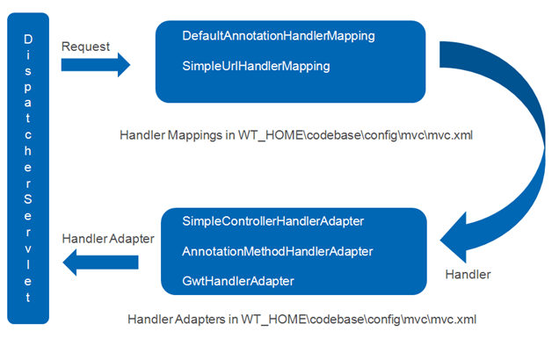

In Windchill we use two handler mappings
• DefaultAnnotationHandlerMapping, which maps handlers based on HTTP paths expressed through the RequestMapping annotation at the type or method level.
• SimpleUrlHandlerMapping which maps from the URLs to request handler beans. Mappings are specified in the properties files at <Windchill>\codebase\config\mvc\
e.g /servlet/WizardServlet* = wizardController
Once the handler is found, it will find the suitable handler adapter from the configured adapters. In Windchill we use three types of handler adapters
• SimpleControllerHandlerAdapter, an adapter to use the plain Controller
• AnnotationMethodHandlerAdapter which maps handler methods based on HTTP paths, HTTP methods and request parameters expressed through the RequestMapping annotation.
• GwtHandlerAdapter, an adapter to handle GWT client requests (handler is RemoteServiceServlet)

Handlers
They are beans that can handle a request. An OOTB handler has been provided to handle requests to build components - com.ptc.mvc.components.ComponentController. It prepares a ModelAndView (org.springframework.web.servlet.ModelAndView) which can be handled by the DispatcherServlet

To build a component, we need its description and the data to be presented. We have introduced the concept of builders, which will provide these artifacts. Component description will be represented via ComponentConfig and a ComponentConfigBuilder provides them. Component data will be represented via ComponentData and a ComponentDataBuilder provide them.

ComponentConfig and ComponentData together define the component information to be shown in the UI and will be represented by ComponentDefintion. It is the Model in MVC paradigm, where as the ComponentController is the Controller.

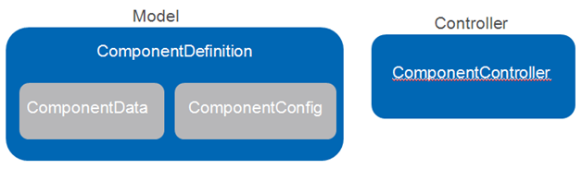

How find a builder?
A typical MVC resource to build a component will be ptc1/<handler_key>/<componentId> where
• handler_key is used to map the request to a handler.
• componentId represent the component to be build.
ComponentController is injected with a ComponentBuilderResolver, which will find the respective builders for the given componentId.

Internal artifacts of ComponentController
Few notable internals of a ComponentController
• ComponentBuilderResolver, finds the ComponentConfigBuilder and ComponentDataBuilder for the componentId specified in the resource
• defaultMappings defines the default views for different ComponentConfig.
• ComponentParamsFactory create ComponentParams from request and response that will be made available in the builders.
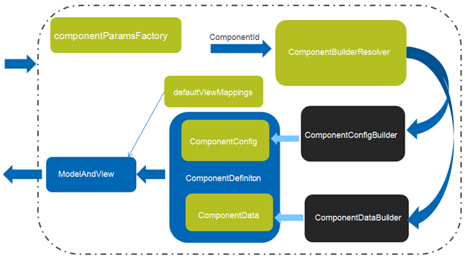

The builders provide ComponentConfig and ComponentData, from which the Model, ComponentDefinition is made. ModelAndView is populated with ComponentDefinition and the view information comes either from the ComponentConfig or from the defaultMapping provided.

The artifacts that are in green are Windchill Client Architecture (e.g JCA) specific ones. The black ones are the ones provided by the component owners.

MVC Components
The components that extend/implement ComponentConfig interface are MVC components. Some of them are :
• TableConfig
• AttributesTableConfig
• TreeConfig
• AttributePanelConfig
• InfoConfig
• ColumnConfig
• PropertyConfig
• PropertyPanelConfig

MVC Builders

There are two types of Builders. The one that provides ComponentConfig are called ComponentConfigBuilder and the one that provides the ComponentData are called ComponentDataBuilder.
• ComponentConfigBuilder :beans that implement com.ptc.mvc.components.ComponentConfigBuilder
• ComponentDataBuilder :beans that implement any of the following interface
◦ com.ptc.mvc.components.ComponentDataBuilder
◦ com.ptc.mvc.components.ComponentDataBuilderAsync
◦ com.ptc.mvc.components.TreeDataBuilderAsync

Specifying the componentid

Typically the component ID that a builder maps to is declared using the @ComponentBuilder annotation in your builder class declaration.
@ComponentBuilder(value = “{<componetId1>, <componetId2>}”)
public class MyBuilder extends … {}

If you wish to implement your config and data builders in separate classes, then you must supply an additional ComponentBuilderType parameter to the @ComponentBuilder annotation.
For config builders, this looks like:
@ComponentBuilder(value=“<componetId>", type=ComponentBuilderType.CONFIG_ONLY)
public class MyConfigBuilder implements ComponentConfigBuilder …. {}
For data builders, this looks like:
@ComponentBuilder(value=“<componetId>", type=ComponentBuilderType.DATA_ONLY)
public class MyDataBuilder implements ComponentDataBuilder… {}

Note that framework will throw an error if two builders will have the same component id. Spring initialization will fail in the MethodServer start up phase. If you need to override an OOTB builder, please use OverrideComponentBuilder annotation.
@ComponentBuilder(value="{compId1, compId2, compId3}")
public class OOTBBuilder1 extends …… {
}
@OverrideComponentBuilder
public class MyCustomBuilder1 extends …… {
}
• MyCustomBuilder1 will be mapped to compId1, compId2, compId3
@ComponentBuilder(value="{compIdA, compIdB, compIdC}")
public class OOTBBuilder2 extends ……{
}
@ComponentBuilder(value="{compIdA, compIdC}")
@OverrideComponentBuilder
public class MyCustomBuilder2 extends ……{
}
@ComponentBuilder(value="{compIdB}")
@OverrideComponentBuilder
public class MyCustomBuilder3 extends ……{
}
• MyCustomBuilder2 will be mapped to compIdA, compIdC
• MyCustomBuilder3 will be mapped to compIdB

TypeBased

To build certain components, you may need the Windchill Type of the context object playing a role in finding the appropriate builder. For example you have an info page and you want to populate the content based on the Windchill Type. For these scenarios, we have introduced an annotation “TypeBased” that can be used in the builder, to attach the builder to a specific Windchill Type. This works with ComponentBuilder.
@ComponentBuilder("compIdA")
@TypeBased(value="{WTPart, WTDocument}")
public class OOTBBuilder1 extends ……{
}
@ComponentBuilder("compIdA")
@TypeBased(“myPart”)
public class OOTBBuilder2 extends ……{
}
• If the context object’s Windchill Type is WTPart and the componentId = “compIdA”, the best match builder for that component is OOTBBuilder1
• If the context object’s Windchill Type is a sub-type of WTPart(myPart) and the componentId = “compIdA”, the best match builder for that component is OOTBBuilder2
• If the context object’s Windchill Type is a sub-type of WTDocument(myDoc) and the componentId = “compIdA”, the best match builder for that component is OOTBBuilder1
While resolving to find the suitable builder, the context object’s Windchill type hierarchy is respected. The attribute value can take
• Internal Name of the Windchill Type
• If the representation has domain name of the exchange container involved, then can use ${internet_domain_name} for its representation. e.g ${internet_domain_name}.DynamicDocument

Registering Builders
Once the builders are created, you need to let Spring infrastructure know about it. Registration can be done either via explicit configuration or by automated scanning. Automated scanning is the preferred approach for typical use cases.
1. Automated scanning: You can configure to automatically pick up all builders within a certain package hierarchy. To do this, add the <mvc:builder-scan/> configuration element to <Windchill>\codebase\config\mvc\custom.xml.
<beans xmlns="xmlns:mvc="http://www.ptc.com/schema/mvc"
xsi:schemaLocation="http://www.ptc.com/schema/mvc
http://www.ptc.com/schema/mvc/mvc-10.0.xsd">
<mvc:builder-scan base-package="com.ptc.windchill.enterprise.
preference.mvc.builders"/>
</beans>
The builder-scan implementation scans the entire classpath, so you should take care to be specific with the package name you declare if using scanning. (don’t scan com.ptc.* for example). In addition, this means that classes that are outside your interest, but that are in the classpath and match the package hierarchy, will also get scanned. From a performance standpoint (MethodServer startup) each scan adds up time. You are requested to take advantage of the OOTB scan provided on “com.ptc.mvc.builders” base package. This means that all the builders that you author should be under com.ptc.mvc.builders package. If you are not using the OOTB scan, the rule of thumb is to use the scan if there are more than 10 builders available in the package.
2. Explicit configuration : To do this, simply add a bean declaration for the builder to the <Windchill>\codebase\config\mvc\custom.xml
e.g <bean class=" my.builder.class.name "/>
You are encouraged not to specify the bean name while declaring the bean and use @ComponentBuilder annotation in the builder for proper registration of it in the Spring bean factory.

Creating Multiple Components

There will be requirement to build multiple components using the same builder and can have two use cases.

Use Case 1
The components are made from an already existing components/builders. For example if there is already a component with id="test.ComponentA" and another with id="test.ComponentB" and we want to get both the components in a page.
@ComponentBuilder(value="test.multi.AB", type=ComponentBuilderType.CONFIG_ONLY)
public class MultiComponentBuilder extends AbstractComponentConfigBuilder{
@Override
public ComponentConfig buildComponentConfig(ComponentParams params)
throws WTException {
MultiComponentConfig configs = new MultiComponentConfig();
configs.addNestedComponent("test.ComponentA");
//you are specifying the componentId
configs.addNestedComponent("test.ComponentB");
configs.setView("/test/multi.jsp");
return config ;
}
}
• There is no need for ComponentDataBuilder as this multiComponent by itself doesn't have any data.
• You need to specify a view jsp for this ComponentConfig as no default view can handle that.
• When you use addNestedComponent to provide a componentId, make sure that componentIds are to be handled by the same controller instance. In other words, you can have only non-type based or type based components combined together with this approach.

Use Case 2
Here the components need to be defined and they exist together. E.g. you want property panel coming with a table.
• There is a need for ComponentDataBuilder.
• Infrastructure invokes the buildComponentData for each ComponentConfig available in the MultiComponentConfig. It’s invoked in the same order it has been put in the MultiComponentConfig.
• You can access the rawData for the ComponentConfig that has already been processed from the ComponentParams supplying the componentId
• You need to specify a view jsp for this ComponentConfig as no default view can handle that.
@ComponentBuilder("test.array.PQ")
public class ComponentArrayBuilder extends AbstractComponentBuilder {
@Override
public ComponentConfig buildComponentConfig(ComponentParams params)
throws WTException {
MultiComponentConfig configs = new MultiComponentConfig();
TableConfig table1 = createTable1();
//create a table with id = component1
......
TableConfig table2 = createTable2();
//create a table with id = component2
......
configs.addComponent(table1);
//add the components
configs.addComponent(table2);
configs.setView("/test/array.jsp");
return configs ;
}
@Override
public Object buildComponentData(ComponentConfig config,
ComponentParams params) throws WTException {
if ("component1".equals(config.getId())) {
//return data for table with id= component1
} else {
//return data for table with id= component2
}
}
}

Data Sources

It’s an infrastructure for holding the data and streaming the data to the client. It will enable faster page loads as well as the potential for asynchronous server processing of results. The basic strategy is to return large result sets to clients in chunks, along with an ID that can be used to get more chunks. With DataSources, the result lives in memory only for as long as it takes the client to request it in chunks.
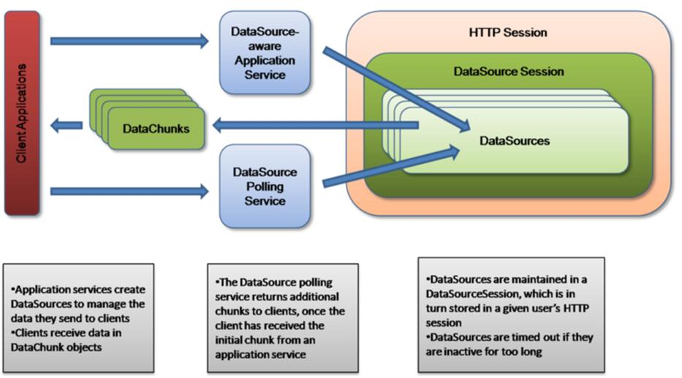

Some of the benefits of using DataSources are
• Display data without overly consuming client- and server-side resources.
• Allow users to interact with the page while data is loading.
• Improve perceived performance.
• Provide messaging and feedback while data is loading.

Modes of Data Sources
Synchronous: This is useful if you have all the data that need to be send to client with you already and want to put the data in DataSource so that it can be send to the clients in chunks. The DataSource session takes in a list of objects that you want sent to the client and returns you a DataChunk object, which contains the first chunk of data to be send to the client. If the List of data could fit in one chunk, then the session doesn't even create a DataSource, it just returns you the chunk. Otherwise a DataSource is created with the data, which can be polled later for additional chunks. The DataSource will be closed so that no more data can be added.

Asynchronous: In this case, you haven't got your data yet. You want to submit a task to get the data in a background thread and have the data returned to the client later. To create an asynchronous DataSource, the DataSource session takes a DataSourceTask which will be run by in a background thread sometime in the future. It returns a DataSourceFuture object, so that you have a way to access the DataSource information.

Disabled: Not DataSource enabled

DataSources with Data Acquisition

Synchronous data sources with Synchronous data acquisition: Uses synchronous data acquisition (all data comes from the database in one chunk) and streams chunks to the client. No blank chunk is sent, so the component is not rendered until the first data chunk is received. Currently we don’t support this for Tree components.

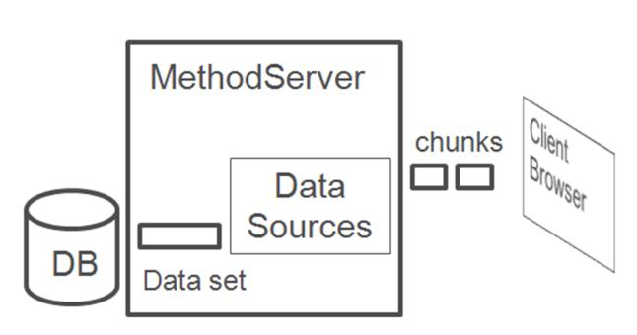

Asynchronous data sources with Synchronous data acquisition: Uses synchronous data acquisition (all data comes from the database in one chunk) and streams chunks to the client. The first chunk sent to the client contains no table data but enables the table to be rendered before a full data chunk is available. This gives the user control of the table and some of its actions sooner. The data chunks then stream in behind the blank chunk as they are processed.

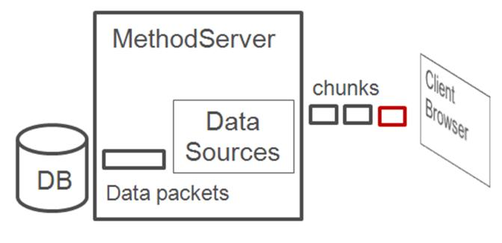

Asynchronous data sources with Asynchronous data acquisition: Uses asynchronous data acquisition (data is obtained from the database in chunks) and streams chunks to the client. The first chunk sent to the client contains no table data but enables the table to be rendered before a full data chunk is available. This gives the user control of the table and some of its actions sooner. The data chunks then stream in behind the blank chunk as they are processed. In this case, we have the potential to see chunks of data rendered in the client while data is still being acquired from the database.
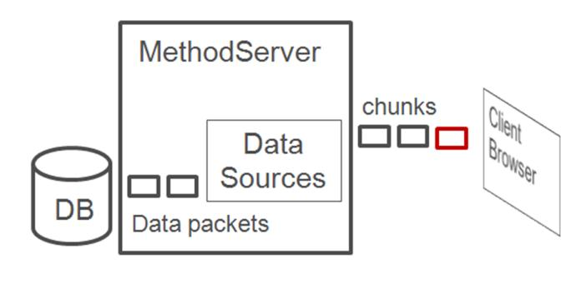
There is change in loading behavior in case of Trees. In Windchill 9.x, we had followed the depth first loading approach where by each node was expanded till its leaf node, before starting to expand it sibling. In Windchill 10, with DataSource, we have moved the Breadth first loading approach. Nodes are loaded per level.
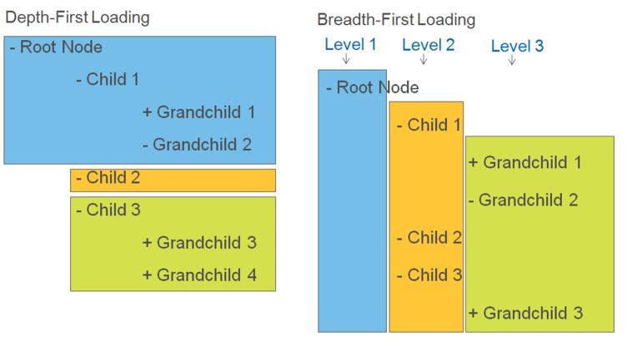

Monitoring Data Sources
DataSourceMonitor MBean can be used to monitor and configure various properties. To find the monitor
• From windchill shell, run “jconsole”
• Select MethodServerMain
• Select MBeans tab
• MBean located at com.ptc>WebAppContexts>${WEBAPP_NAME}>Monitors>DataSourceMonitor

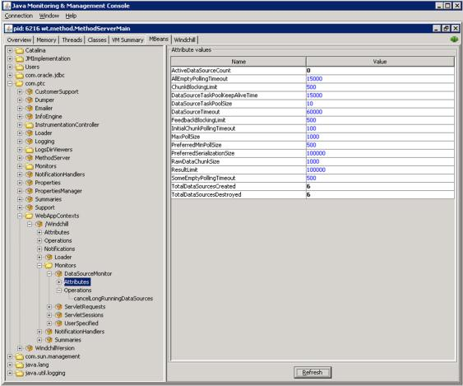

MBean monitoring
Parameter | Description
ActiveDataSourceCount | The number of datasources that currently are active in all user sessions
TotalDataSourcesCreated | The total number of DataSources that have been created for all user sessions
TotalDataSourcesDestroyed | The total number of DataSources that have been destroyed for all user sessions

MBean operations
Parameter | Description
cancelLongRunningDataSources | Cancel any datasources that have been running for at least the given amount of milliseconds, in all user sessions. This will cancel both active and inactive DataSources

MBean configuration

Parameter | Description
AllEmptyPollingTimeout | The timeout in milliseconds to wait for data chunks when the client polls for chunks and none of the ids it asked for have chunks available
ChunkBlockingLimit | Controls the number of chunks a DataSource can hold before it blocks the addition of more items until something polls it or it times out. The actual number of items this resolves to is ChunkBlockingLimit*MaxChunkSize.
DataSourceTaskPoolKeepAliveTime | The amount of time in milliseconds to keep idle threads alive in the DataSource task pool
DataSourceTaskPoolSize | The maximum number of threads allowed in the DataSource task pool
DataSourceTimeout | The amount of time in milliseconds to keep idle DataSources alive
FeedbackBlockingLimit | The number of feedback items a DataSource can hold before it blocks the addition of more feedback until something polls it or it times out
InitialChunkPollingTimeout | The amount of time in milliseconds to wait to for the initial chunk of data to be available, when using asynchronous datasources. This enables components to try and display some data in the table on initial rendering if possible
MaxPollSize | The maximum size of data that is returned by a DataSource for each poll.
PreferredMinPollSize | The minimum size of data for a poll. This is used when polling asynchronous datasources, to allow the server to decide whether to wait for more data or not
PreferredSerializationSize | The preferred size in bytes of the total response to a polling request. If the initial chunks do not reach this size limit, then additional chunks are added until they are over the limit. This property is not currently used.
ResultLimit | The total number of items that can be added to a DataSource before it fails.
SomeEmptyPollingTimeout | The timeout in milliseconds to wait for data chunks when the client polls for chunks and some of the ids it asked for have chunks available, but not all of them
TreeChildNodeFetchTimeout | The timeout in miliseconds to wait for child data for the tree. The OOTB value is 180000 ms and can be increased to avoid time out errors.

Persisting the updated MBean Configuration values

It is possible to persist the updated configuration values of "DataSourceMonotor" MBean in the XML.
• Open Jconsole and change any of the configurable value of "DataSourceMonitor" MBean.
• Click on the "DataSourceMonitor" MBean. From the MBeanInfo, copy the "ObjectName".
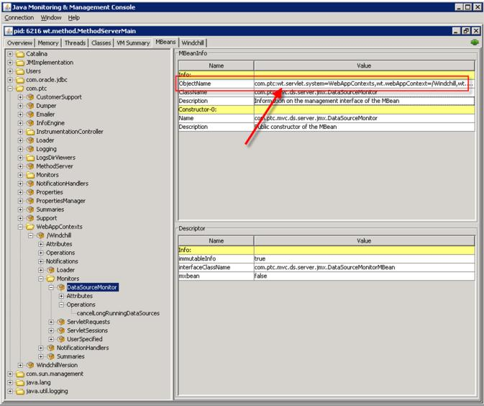

• Open the Loader MBean com.ptc > WebAppContexts >${WEBAPP_NAME}
• Got to its "Operation invocation" tab.
• Paste the "ObjectName" as a parameter for "addInjectionTargetMBean" method and click on the "addInjectionTargetMBean" button.

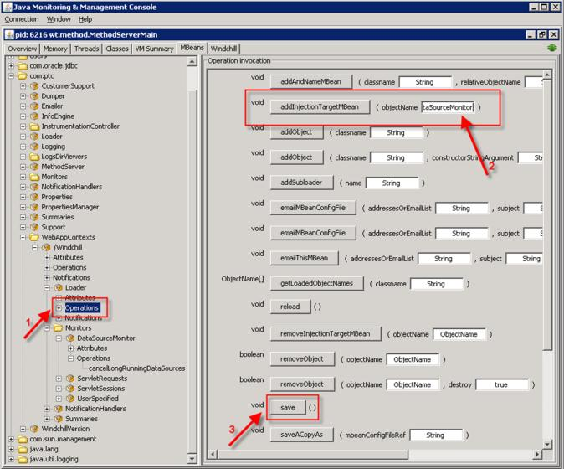

• Now click the "Save" button. The changed value of the "DataSourceMonitor" MBean will get persisted in the <WTHome>/codebase/WEB-INF/wtWebAppMBeans.xml file. On any subsequent server restart, the last saved value will show up the in "DataSourceMonitor" MBean.
• Configurable properties can be reverted back to the default values by invoking "removeInjectionTargetMBean" method with the "ObjectName", followed by a “save” operation.

JCA Components

These are few implementation of ComponentConfig :
• JcaTableConfig
• JcaAttributesTableConfig
• JcaTreeConfig
• JcaAttributePanelConfig
• JcaColumnConfig
• JcaInfoConfig
• JcaPropertyConfig
• JcaPropertyPanelConfig

JCA Configurations for MVC
All the JCA specific Spring configurations are available in <Windchill>\codebase\config\mvc\jca-mvc.xml. The below snippet shows the configuration of url handler mapping. All the url pattern ptc1/comp/* are mapped to a bean with id componentController and the pattern ptc1/tcomp/* are mapped to a bean with id typeBasedComponentController.
<bean id="abstractComponentHandlerMapping" abstract="true"
class="org.springframework.web.servlet.handler.SimpleUrlHandlerMapping">
-----
</bean>
<bean id="componentHandlerMapping" parent="abstractComponentHandlerMapping">
<property name="mappings" ref="componentHandlerMappings" />
-----
</bean>
<bean id="componentHandlerMappings"
class="org.springframework.beans.factory.config.PropertiesFactoryBean">
<property name="properties"><props>
<prop key="/comp/**">componentController</prop>
<prop key="/tcomp/**">typeBasedComponentController</prop>
</props></property>
</bean>

Below snippet shows the definition of the bean with componentController id.
• jcaComponentBuilderResolver is injected as theComponentBuilderResolver
• defaultViewMappings property is defined to map the default views
<bean id="componentController"
class="com.ptc.mvc.components.ComponentController">
<property name="componentBuilderResolver"
ref="jcaComponentBuilderResolver" />
<property name="defaultViewMappings">
<map>
<entry key="com.ptc.mvc.components.TreeConfig"
value="/components/tree.jsp" />
<entry key="com.ptc.mvc.components.TableConfig"
value="/components/table.jsp" />
<entry key="com.ptc.mvc.components.AttributesTableConfig“
value="/components/table.jsp" />
<entry key="com.ptc.mvc.components.AttributePanelConfig”
value="/components/attributePanel.jsp" />
</map>
</property>
-----------
</bean>

Below snippet shows the definition of the bean with typeBasedComponentController id.
• typeBasedComponentBuilderResolver is injected as the ComponentBuilderResolver. It respects the Windchill Type of the context object also while finding the best matched builder.
<bean id="typeBasedComponentController"
class="com.ptc.mvc.components.ComponentController“
parent="componentController“>
<property name="componentBuilderResolver"
ref="typeBasedComponentBuilderResolver" />
</bean>
The default handler specified will handle all the MVC url patterns that doesn’t have a mapping.
<bean id="componentHandlerMapping" parent="abstractComponentHandlerMapping">
<property name="defaultHandler" ref="netmarketsController" />
-----
</bean>
<bean id="netmarketsController"
class="com.ptc.jca.mvc.controllers.LegacyController" />

ComponentConfigFactory

Builders which are ComponentConfigFactoryAware will be injected with a ComponentConfigFactory. ComponentConfigFactory provides instances of different implementations of ComponentConfig (eg table, tree etc). In JCA, the injection happens in the bean post processor and is configured in <Windchill>\codebase\config\mvc\jca-mvc.xml.
<bean class="com.ptc.mvc.components.support.ComponentBuilderBeanPostProcessor">
.....
<property name="componentConfigFactory" ref="jcaComponentConfigFactory" />
<property name="infoComponentConfigFactory">
......
</property>
<property name="typedAttrLayOutFactory">
<bean class="com.ptc.jca.mvc.components.JcaTypedAttrLayOutFactory" />
</property>
</bean>
<bean name="jcaComponentConfigFactory"
class="com.ptc.jca.mvc.components.JcaComponentConfigFactory"
factory-method="getInstance" />

ComponentDataConvertor

<bean id="jcaComponentDataConverter"
class="com.ptc.jca.mvc.components.JcaComponentDataConverter" />
<bean id="jcaComponentDataBuilder"
class="com.ptc.jca.mvc.components.DefaultJcaComponentDataBuilder"
scope="prototype">
<property name="componentDataConverter"
ref="jcaComponentDataConverter" />
</bean>
<bean id="jcaComponentBuilderResolver“
class="com.ptc.jca.mvc.components.JcaComponentBuilderResolver">
......
<lookup-method name="createJcaDataBuilder"
bean="jcaComponentDataBuilder" />
</bean>
The data that is available from the ComponentDataBuilder need to be processed so that it can be consumed by JCA. Running the data through the dataUtilities happen in this stage. JcaComponentDataConverter does that and is injected into the jcaComponentBuilderResolver.

ComponentBuilder Resolver
• If the DataBuilder specified is an instance of ConvertingComponentDataBuilder, JcaComponentBuilderResolver uses that as the ComponentDataBuilder.
• If the DataBuilder specified is an instance of ComponentDataBuilder, JcaComponentBuilderResolver uses that as the internal builder for the DefaultJcaComponentDataBuilder.
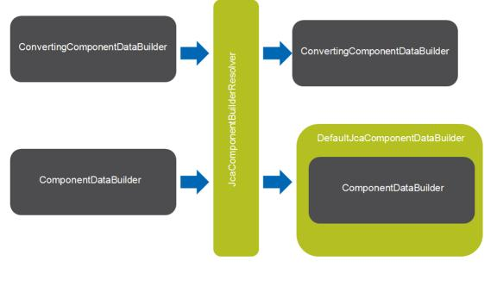

Generate MVC URLs
There are two types of JCA MVC urls.
• Non TypeBased JCA MVC url : Here the context object doesn’t participate in the builder resolution process.
• TypeBased JCA MVC url : Here the context object’s type participate in the builder resolution process.
This is generated using action definition
<action>
<component name="myCompId" ……/>
</action>
<action>
<component name="myCompId" " typeBased="true" ……/>
</action>
e.g
<action name="CustEx_mvc_table">
<component name="carambola.mvc.table" windowType="page" />
</action>
<action name="primaryAttributes" resourceBundle="com.ptc.core.ui.navigationRB">
<component name="primaryAttributes" typeBased="true" windowType="page"/>
---
</action>
<Windchill>/codebase/ WEB-INF/tlds/mvc.tld has helper functions that can be used
<%@ taglib uri="http://www.ptc.com/windchill/taglib/mvc" prefix="mvc"%>
---
<jsp:include page="${mvc:getComponentURL('part.report.multiLevelBOM')}" />

Table Size Limit

The maximum number of rows displayed in a table is driven by this preference which has a USER level visibility. It will be applicable to all the JCA tables in the system. Currently the OOTB default value is 2,000 rows and you can vary it based on client hardware and browser type.
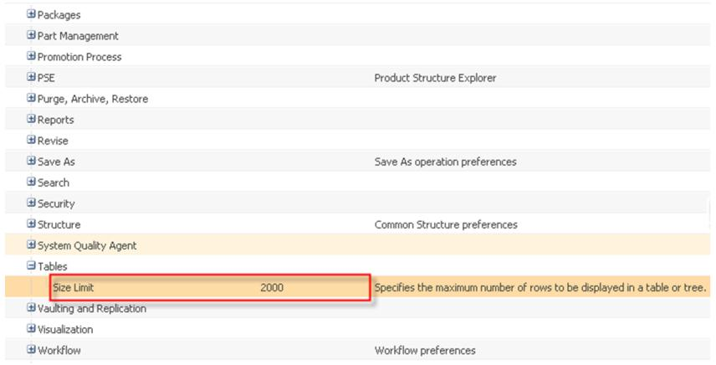

For trees, the limit is enforced but can be overridden by the end users. Once the tree reaches the size limit, collapse of any node will remove its children from the client, to free some resource in the client. This will happen till the number of nodes in the client comes below the size limit.
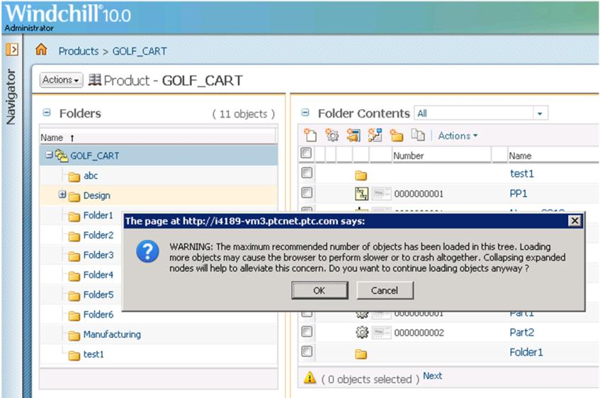

Action Handling
Actions can be broadly divided into three groups.
These actions can be performed once your objects are loaded.
• Group 1 – Actions which act only on loaded data
◦ Row-level and multi-select actions
◦ Select all, Ctrl/Shift select, Clear all
◦ View selected objects only
• Group 2 – Actions which act on the entire data set
These actions can be performed anytime (If incomplete data set, goes to the server to get all the data)
◦ Switching table views
◦ Search in table
◦ Export list
• Group 3 – Actions which apply to the table itself
These actions can be performed anytime
◦ Create actions
◦ Cancel data loading
◦ Save table view

Sorting

Sorting is a special action and with DataSource, depends on the data in the client.
• If complete data set
◦ Sorting happen in the client
• If data still loading
◦ Sorting happen on the data already in the client
◦ Insert remaining polling rows into the client in sorted order
• If results limit was reached
◦ Sorting happen in the client
◦ Only the rows that are in the client are sorted (not the complete data set)
• Version column is an exception, which makes a server trip to do the sorting, but only on the data set available in the client.

Tips
Enabling Spring Logging
Please add the following entry in <Windchill>\codebase\WEB-INF\log4jMethodServer.properties and restart the server.
log4j.logger.org.springframework=DEBUG

Accessing Localized Messages
ResourceBundleClientMessageSource can be used to get the localized messages.
String resourceBundle = "com.ptc.test.TestResource";
ClientMessageSource messageSource =
new ResourceBundleClientMessageSource(resourceBundle);
String message = messageSource.getMessage(TestResource.TEST);
Entry in the TestResource file
@RBEntry("Test Message")
public static final String TEST = "test";
If your builder extends OOTB abstract builders, take advantage of its api
AbstractComponentConfigBuilder.getMessageSource(String resourceBundle)
AbstractComponentDataBuilder.getMessageSource(String resourceBundle)
AbstractInfoConfigBuilder.getMessageSource(String resourceBundle)

Storing View Components
All the view jsps should be placed under <Windchill>\WEB-INF\jsp and the value you specify while specifying it should be relative to <Windchill>\WEB-INF\jsp.
table.setView("/carambola/carambolaMVCExampleTable.jsp");

Requesting the Nm*Bean in JCA Component Builders
NmHelperBean helper = ((JcaComponentParams) params).getHelperBean();
NmCommandBean nmCommandBean = helper.getNmCommandBean();
HttpServletRequest request = nmCommandBean.getRequest();

Thread Safety of Builders
By default the builders follow the thread safety paradigm of servlets (Singleton scope), meaning that instance variables in your builders must be thread-safe. Communication between your config and data builder APIs can be done through either the config object itself, or via ComponentParams.
public class TestComponentBuilder extends AbstractComponentBuilder{
@Override
public ComponentConfig buildComponentConfig(ComponentParams params)
throws WTException {
Object myObject;
//add information that you want to pass to data builder
params.setAttribute("myKey", myObject);
-----
}
@Override
public Object buildComponentData(ComponentConfig config,
ComponentParams params)
throws WTException {
//get the information that was put in config builder
Object myObject = params.getAttribute("myKey");
-----
}
}

MVC Tables

MVC Tables are discussed in Constructing and Rendering a Table Using the JSP Framework.

Customizing HTML Clients Using the Windchill JSP Framework

This chapter explains and gives some basic overview of the Windchill Client Architecture UI Framework.

Customizing Generic Aspects of JSP Pages

This section contains the following topics:
• Customizing the UI with Ajax

Customizing the UI with Ajax

Objective
This section will describe how to dynamically update a portion of a Windchill page by:
1. Using the partial page refresh capabilities built into the Windchill action and form processing frame workor
2. Making an Ajax call to the Method Server directly from your JavaScript code.

Scenario 1

A UI component on your page executes an action. When the action completes, you would like to update a portion of the launch page to reflect the results of an action.

• Example: A user launches a wizard to create a new part from the folder browser of a product. When the user clicks OK you send the form to the server and create the part. After doing so, you would like to add a row to the folder browser table that displays the part just created.

• Example: A user clicks a menu item in a product folder browser to delete a document. The menu item action calls a command to delete the object from the database. When the command completes, you would like to delete the row for that object from the folder browser table.

• Solution: Use the partial page refresh capabilities built into the Windchill action and form/command processing framework

Scenario 2

You would like to refresh an inline element of the page when some event occurs
• Example: You have a page that displays time values in a default time zone. It also has a button that allows the user to change the time zone. When the user changes the time zone, you want to redisplay the time values accordingly.
• Solution: Add an onChange event handler for the time zone button that calls the requestHandler.doRequest() JavaScript function to recompute the time display value.
Background
To make the Windchill product faster and more scalable, it is necessary to use some Ajax based operations to cut down on the refresh times of pages. All actions should be Ajax based where possible. The only actions that should not be Ajax based are those that require most of the page to be updated.

Solution

Specify some Ajax based configuration and code in the action to allow the Ajax refresh to work.

Solution Elements

Element | Type | Description
<your actions>.xml | XML | XML file that defines menu, toolbar, wizard, and other actions in the Windchill action framework
<your>formProcessor.java | Java | A processor that performs operations based on user data submitted in a wizard
<your wizard step>.jsp | Jsp | Jsp to partially refresh in a wizard
FormResult | Java | A class used to communicate results from a form processor back to the framework.
DynamicRefreshInfo | Java | A class that provides information about the type of partial refresh that should be done.  The information included is:  • Oid : the oid that was just created/updated/deleted. (the new oid in the case of update)  • locationOid : the oid of the parent location where the object was just created/deleted in a tree, or the oid of the original in the case of update, or just null otherwise  • action : add, update or delete. Use the NmCommandBean constants: DYNAMIC_ADD, DYNAMIC_UPD, DYNAMIC_DELETE
DynamicNmContextRefreshInfo | Java | Tree specific specialization of the DynamicRefreshInfo for handling tree paths.

Refresh a row in a table
In the class <your>formProcessor.java, return some dynamic refresh Info in the FormResult:
DynamicRefreshInfo di = new DynamicRefreshInfo (newOid,oid,NmCommandBean.DYNAMIC_UPD) ;
result.addDynamicRefreshInfo(di);
return result;
Note that rows can be added and removed from the table by switching the flag on the refreshInfo to be NmCommandBean.DYNAMIC_ADD or DYNAMIC_DELETE respectively.

Special Tree Refresh Instructions
The second OID or context object passed to the tree refreshInfo is specified to be the parent row. So in the case of adding a row to a tree, it is necessary to specify which parent folder to show the new item under.

Refresh the whole table
Add a component specific onAfterAction event listener for this action to make the appropriate call to refresh a certain part of the window such as PTC.navigation.reload(). One example in the product is the onAfterAction listener on the miniNavigator which refreshes the whole miniNavigator component for many actions: PTC.miniNavigator.onAfterAction.

Making an Ajax Call in Windchill

You can make your own Ajax request to the server for data whenever the techniques described above do not meet your needs.

Element | Type | Description
requestHandler.doRequest | Javscript | A Javascript “class” with methods for making Ajax requests
getElementHtml | Javascript | Javascript function that can update part of the page. Uses the requestHandler to fetch the new html from the server.

Procedure – Making an Ajax Call

To make Ajax calls in Windchill, use the requestHandler.doRequest() JavaScript method. You provide this method with the URL to call on the server and other optional parameters, if desired. It returns a response, which is a JavaScript XMLHttpRequest object.

The following example shows how this method is used in Windchill to reset a hidden field in the DOM called “itemTypeInstanceId” when the user changes the value in the object type picker of an object creation wizard.
<script>
.
.
.
var params = ‘pickerVal=’ + elementVal; // elementVal is the new value of the type picker
var options = {
asynchronous: false,
parameters: params
};
var url = “netmarkets/jsp/components/resetItemTypeInstanceId.jsp”;
var response = requestHandler.doRequest(url, options);
var newTypeInstanceId = response.responseText;
element = document.getElementById(currentObjectHandle +
“itemTypeInstanceId”);
element.value = newTypeInstanceId;
.
.
.
</script>
In this case, the “pickerVal” parameter is passed to the jsp in the request parameters. The jsp makes a call to a server method to compute a new TypeInstanceIdentifier for the object and passes it back in the response:
<%
String pickerChoice = request.getParameter("pickerVal");
String typeInstanceIdentifier =
createBean.getNewTypeInstanceIdStringForNewItem(pickerChoice);
out.clearBuffer();
out.write(tiid);
out.flush();
%>
By default, doRequest() will make an asynchronous request so that page processing is not blocked while waiting for a response. If you want the request to be synchronous you must set asynchronous to false in the options passed to the method, as shown above.
If the request is to be asynchronous, you will need to provide a JavaScript function to call when the response is received successfully in the options parameter to doRequest(). For example:
var options={
asynchronous: true,
parameters: 'oid=' + oid,
onSuccess: function(response) {
var response = response.responseText;
var json = response.evalJSON();
var locationValue = json.locationValue;
var folderOid = json.folderOid;
setFolder(window, locationValue, folderOid);
}
};
In the example above, the jsp that is invoked calls a Java tag that writes a JSON object to the response.
<req:getFolderAndContactByOidTag oidString="${param.oid}" />
Rather than define the onSuccess function inline, you can just specify the name of a function to be called:
onSuccess: handleResponse,
In addition to an onSuccess callback, you can optionally specify a onFailure callback function. If you do not specify an onFailure callback, the error response will just be logged to the JavaScript console.

Procedure - Batching Ajax Requests

If you have to make many Ajax requests to the same URL, you can batch them using a JavaScript BatchRequest object to reduce network traffic. When you create a BatchRequest object, you pass it a configuration object telling it the maximum number of requests to send in one batch request, the URL to call to process the requests, and the callback methods for success or failure.

You then add requests to the BatchRequest object. When either the maximum batch size is reached or 500 milliseconds has elapsed, the batch request will automatically be sent asynchronously to the server. In the meantime, you can continue adding requests to the BatchRequest object.

The BatchRequest object will exist for the life of the page in which it is invoked. When the user navigates away from the current page, the BatchRequest will be killed and any unprocessed requests will be deleted.

Below is an example of how to create a BatchRequest in JavaScript. See numericJSRenderer.jsfrag for the complete method.
try {
if(!jsca.columns.numericRenderer.batchRequests) {
jsca.columns.numericRenderer.batchRequests = new PTC.jca.
batch.BatchRequest({
url: getBaseHref() + "ptc1/numeric/",
maxBatchSize: 50,
successCallback: function(response) {
var result = PTC.decode(response.responseText);
for (var i=0,length=result.length; i < length; i++) {
$(jsca.columns.numericRenderer.uniqueIdPrefix +
result[i].uniqueId).innerHTML =
result[i].displayValue;
}
},
failureCallback: function(response) {
jsca.columns.numericRenderer.log.error
("ERROR in jsca.columns.numericRenderer()
getting numeric component data for displaying.");
}
});
}
} catch(e) {
// Handle error that could be thrown when creating BatchRequest
}

Once the request is created, you call its addRequest() method to add requests to it, passing it the parameters you would send to the requestHandler.doRequest() method.
jsca.columns.numericRenderer.batchRequests.addRequest({
type : data.type,
externalForm : data.rawValue,
isPercent : data.isPct,
isCurrency : data.isCurrency,
uniqueId : uniqueId
});

In this example, the batched requests are sent to a servlet engine controller class called “NumericController”. The individual requests provide information about a number value that needs to be displayed on the page. The controller loops through the individual requests, calls a Java class to create a localized display value for the number, and returns a JSONArray of JSONObjects, each of which contains a display value and a unique id corresponding to the id of a HTML div tag on the page. The success callback function replaces the contents of the div tags with the display values.
If you use a controller class to process the batch request, it should be annotated with the Spring @Controller and @RequestMapping annotations. Here is a portion of the NumericController class (see NumericController for the complete class).:
import org.springframework.stereotype.Controller;
import org.springframework.web.bind.annotation.RequestMapping;
import org.springframework.web.bind.annotation.RequestMethod;
import org.springframework.web.bind.annotation.RequestParam;
.
.
.
@Controller
@RequestMapping(value = "/numeric/**")
public class NumericController {
@RequestMapping(method = { RequestMethod.POST, RequestMethod.PUT })
protected void convertToString(
@RequestParam("data") final String data,
HttpServletRequest request, HttpServletResponse response) throws IOException {
JSONArray result = new JSONArray();
try {
JSONArray requests = new JSONArray(data);
for (int i = 0; i < requests.length(); i++) {
JSONObject req = requests.getJSONObject(i);
try {
String type = req.getString("type");
String externalForm = req.getString("externalForm");
String isPercent = req.optString("isPercent");
String isCurrency = req.optString("isCurrency");
String uniqueId = req.getString("uniqueId");
String displayValue = NumericFormat.formatValueForDisplay(type,
externalForm,
Boolean.valueOf(isPercent), Boolean.valueOf(isCurrency));
JSONObject singleResponse = new JSONObject();
singleResponse.put("displayValue", displayValue);
singleResponse.put("uniqueId", uniqueId);
result.put(singleResponse);
} catch (Exception e) {
.
.
.
}
}
response.setContentType("application/json; charset=UTF-8");
PrintWriter out = response.getWriter();
out.print(result.toJSONString());
} catch (Exception e) {
log.error("Problem displaying and formatting
number in NumericController.", e);
}

Refreshing a Large Block of the Page

There is often the need to refresh a section of the page without a full page refresh. In this case there are some helpful javascript functions. In particular, the getElementHtml function is optimized to replace the innerHTML of the given div id with the response from the given url. If the div id is in the response, only the innerHTML of the div will be used as the replacement. See the jsDoc for more information about this function:.
getElementHtml( params, divId, true, url)

Sample Code

Examples of usage in out-of-box code. Many examples exist, search actions.xml files for ajax=”component” ajax=”row” or the processors for calls to addDynamicrefreshInfo.

Bread Crumbs Component

You can create a list of navigation bread crumbs at the top of a Windchill page.
A list of “bread crumbs” is displayed at the top of many Windchill pages. These bread crumbs show the location of the page in the page hierarchy. Each crumb is a link that will take the user to the corresponding page in the hierarchy.
Example bread crumb list:


See the package javadoc for com.ptc.windchill.enterprise.navigation.breadcrumb for information on the classes and process used to produce bread crumbs.

Scope/Applicability/Assumptions
This process should be applied when you want to create bread crumbs for one or more Windchill pages that do not currently have bread crumbs or you want to modify the bread crumbs displayed on a Windchill page.

Intended Outcome
Bread crumbs are displayed as desired

Solution
Create and register a BreadCrumbDelegate Java class with an inner class that extends AbstractBreadCrumbGenerator to display the bread crumbs.

Prerequisite Knowledge
To create the necessary bread crumb classes you will need an understanding of the Java programming language.

Solution Elements
Element | Type | Description
BreadCrumbController | Java class | The controller class that receives AJAX requests for bread crumbs. It returns a response that is the string form of a JSON array of crumbs.
BreadCrumbDelegateFactory | Java class | A factory used by the BreadCrumbController to locate a BreadCrumbDelegate capable of producing the bread crumbs for a given page.
BreadCrumbDelegate | Java interface | A delegate that contains an inner AbstractBreadCrumbGenerator class and that knows which pages the generator class can produce bread crumbs for.
AbstractBreadCrumbGenerator | Java class | A subclass of this base class creates the bread crumbs for a page.
*.wt.properties.xconf | Properties xconf file | Contains the property “com.ptc.windchill.enterprise.breadcrumb.BreadCrumbDelgate” that lists all available BreadCrumbDelegates.

Procedure — Creating a New BreadCrumbDelegate Class

Creating the BreadCrumbDelegate Class
Bread crumb delegate classes should implement the BreadCrumbDelegate interface. This interface has two methods: canHandle() and getGenerator().
• The canHandle() method is called by the BreadCrumbDelegateFactory to determine if the delegate’s inner AbstractBreadCrumbGenerator class (see below) is capable of producing bread crumbs for a given page. The canHandle() method is passed the page URL, the context object from the URL, if any, and the container object from the URL, if any. It should return true or false.
• The BreadCrumbController calls the getGenerator() method of the delegate chosen by the factory to get a new instance of its inner AbstractBreadCrumbGenerator class.

Since the factory creates only one static instance of each delegate, the delegate class itself should not use class instance variables or be stateful in any way.

Creating the AbstractBreadCrumbGenerator Inner Class
Your delegate class should have an inner class that is a subclass of AbstractBreadCrumbGenerator. The getCrumbs() method of the inner class will be called by the BreadCrumbController to generate the JSONArray of crumbs. A new instance of the inner generator class will be created each time it is called so generator classes may be stateful.
The constructor of the generator class will be passed the URL of the page, the context object for the page, if given on the URL, and the container for the page, if given on the URL. The constructor should call the init() method of the superclass.
The JSON objects returned in the array by the getCrumbs() method should have the following format:
{text: 'display text', url: 'http://my/url'}
For example:
[{"text":"Products","url":"app/#ptc1/comp/netmarkets.product.list"},{"text":"Product1","url":"http://<someServer>/Windchill/app/#ptc1/tcomp/infoPage?oid=OR%3Awt.pdmlink.PDMLinkProduct%3A105250&u8=1"}]
See Sample Code for example classes.

Procedure — Registering the BreadCrumbDelegate

To register your BreadCrumbDelegate you must add it to the list of delegates contained in the wt.property “com.ptc.windchill.enterprise.navigation.breadcrumb.BreadCrumbDelegate.” This property is defined as follows:
<Property name="com.ptc.windchill.enterprise.navigation.breadcrumb. BreadCrumbDelegate" multivalued="," default= "com.ptc.windchill.enterprise.navigation.breadcrumb. FolderedBreadCrumbDelegate" />
The default delegate, FolderedBreadCrumbDelegate, is the delegate that will be called if no other delegate claims a page. The value of the default delegate is hard-coded and cannot be changed. Changing the value in the property will have no effect.

Additional delegates may be added to the delegate list in a custom or module-specific *.xconf file using the AddToProperty tag. For example:
<AddToProperty name="com.ptc.windchill.enterprise.navigation.breadcrumb.BreadCrumbDelegate value="com.ptc.windchill.enterprise.navigation.breadcrumb.
WorkspaceBreadCrumbDelegate~10"/>
You can optionally assign a priority to a delegate, as shown above, by appending a ‘~’ followed by a priority value to the delegate class name. A priority value may be any number less than Integer.MAX_VALUE; the lower the number, the higher priority. To see the priorities of existing delegates you can look at the composite property value in <Windchill>/codebase/wt.properties.

The BreadCrumbDelegateFactory will call the canHandle() methods of delegates in priority order until it finds one that responds affirmatively. Therefore, if there are multiple delegates that could generate the crumbs for a given page, the one with the highest priority will be used. If multiple delegates have the same priority, they will be called in random order. The canHandle() method of delegates which do not have a “~<priority>” suffix will be called last, in random order.

Sample Code
The following code is extracted from the AssignmentsBreadCrumbDelegate which generates the bread crumbs for an task (WorkItem) object.
public class AssignmentBreadCrumbDelegate implements BreadCrumbDelegate {
@Override
public boolean canHandle(Persistable contextObject, WTContainer container,
String url)
throws WTException {
if (contextObject instanceof WorkItem || contextObject instanceof
ActionItem) {
return true;
}
return false;
}
@Override
public AbstractBreadCrumbGenerator getGenerator(Persistable contextObject,
WTContainer container, String url) throws WTException {
return new AssignmentCrumbGenerator(p, container);
}
public class AssignmentCrumbGenerator extends AbstractBreadCrumbGenerator {
/**
* IDs for Assignment list components.
*/
protected static final String PRODUCT_ASSIGNMENTS_LIST_ID =
"netmarkets.product.assignments.list";
protected static final String LIBRARY_ASSIGNMENTS_LIST_ID =
"netmarkets.library.assignments.list";
protected static final String QUALITY_ASSIGNMENTS_LIST_ID =
"com.ptc.qms.listAssignments";
protected static final String PROJECT_ASSIGNMENTS_LIST_ID =
"project.assignments";
protected WTContainer container;
/**
* Initialize as a generator and set instance variable
* container so that the Assignments crumb can be made.
* First tries to set container to c. Next
* tries to set container to contextObject's container (if
* contextObject is WTContained). Next tries to set
* container to contextObject's source object's container.
* Lastly tries to set container to contextObject's
* primary business object container.
*
* @param contextObject
* @param c
* @throws WTException
*/
public AssignmentCrumbGenerator(Persistable contextObject,
WTContainer c)
throws WTException {
init();
// If no container is passed in, try to get it from contextObject.
if (c == null && contextObject!= null) {
WTContained containedItem = null;
if (contextObject instanceof WTContained) {
// This will either be an ActionItem (which is contained)
// or could possibly be a future WorkItem, if it ever
// implements WTContained.
containedItem = (WTContained) contextObject;
} else if (contextObject instanceof WorkItem) {
// Use the WorkItem's source if it is contained.
ObjectReference sourceRef = ((WorkItem)
contextObject).getSource();
if (sourceRef != null) {
Persistable source = sourceRef.getObject();
if (source instanceof WTContained) {
containedItem = (WTContained) source;
}
}
// If there is still no containedItem, try use the
// WorkItem's primary business object.
if (containedItem == null) {
PersistentReference primaryObjectRef = ((WorkItem)
contextObject)
.getPrimaryBusinessObject();
if (primaryObjectRef != null) {
Persistable primaryObject = primaryObjectRef
.getObject();
if (primaryObject instanceof WTContained) {
containedItem = (WTContained) primaryObject;
}
}
}
}
if (containedItem != null) {
c = containedItem.getContainer();
}
}
container = c;
}
@Override
public JSONArray getCrumbs() {
try {
addContainerCrumbs(container);
} catch (Exception e) {
log.error("Couldn't create the crumbs for container "
+ container, e);
addCrumb(getSecuredInfoCrumb());
}
try {
addCrumb(createAssignmentsCrumb());
} catch (Exception e) {
log.error("Couldn't create the Assignments Table crumb.", e);
addCrumb(getSecuredInfoCrumb());
}
return crumbs;
}
/**
* Makes the Assignments List crumb for a given assignment object.
*
* @return JSONObject
* @throws WTException
* @throws JSONException
*/
protected JSONObject createAssignmentsCrumb() throws JSONException,
WTException {
if (container == null) {
log.warn("The Assignments list crumb will not be made because
container is null.");
return null;
}
String url = getAssignmentsListUrl(container);
String localizedText = navigationBundle
.getString(navigationRB.ASSIGNMENTS);
return createCrumb(url, localizedText);
}
/**
* Given a container, will return a URL for the assignment list
table.
* Example:
* app/#ptc1/comp/netmarkets.product.assignments.list?
oid=OR%3Awt
* .pdmlink.PDMLinkProduct%3A12345&u8=1
*
* @param container
* @return String
*/
protected String getAssignmentsListUrl(WTContainer container) {
String url = "";
if (container instanceof PDMLinkProduct) {
url = MVCUrlHelper.getComponentURL(PRODUCT_ASSIGNMENTS_
LIST_ID);
} else if (container instanceof Project2) {
// Could be project or program. Same URL in either case.
url = MVCUrlHelper.getComponentURL(PROJECT_ASSIGNMENTS_
LIST_ID);
} else if (container instanceof WTLibrary) {
WTLibrary libObj = (WTLibrary) container;
if (libObj.isQMSTypeContainer()) {
// If Quality container then navigate to Quality
Assignment
// page
url = MVCUrlHelper
.getComponentURL(QUALITY_ASSIGNMENTS_LIST_ID);
} else {
// If Library container then navigate to Library
Assignment
// page
url = MVCUrlHelper
.getComponentURL(LIBRARY_ASSIGNMENTS_LIST_ID);
}
} else {
// This is the case where container is null or of unsupported
// container type.
return null;
}
url = url.replaceFirst("/", MVCUrlHelper.APPPREFIX);
String containerOid = "OR:"
+ container.getPersistInfo().getObjectIdentifier()
.toString();
try {
containerOid = URLEncoder.encode(containerOid, "UTF-8");
} catch (UnsupportedEncodingException e) {
log.error("Could not encode the container oid.", e);
}
url += "?oid=" + containerOid + "&u8=1";
return url;
}
}
}

Additional Resources

Related Package/Class Javadoc
• com.ptc.jca.mvc.controllers.BreadCrumbController
• com.ptc.windchill.enterprise.navigation.breadcrumb.BreadCrumbDelegateFactory
• com.ptc.windchill.enterprise.navigation.breadcrumb.BreadCrumbDelegate
• com.ptc.windchill.enterprise.navigation.breadcrumb.AbstractBreadCrumbGenerator
• com.ptc.windchill.enterprise.navigation.breadcrumb.FolderedBreadCrumbDelegate

Packaged Samples
This section contains information on the sample code that is provided within the system.

Bread Crumbs Based on the Context Object

This example shows how bread crumbs can be created based on the context object of the page. The bread crumbs for this example were created by the FolderedBreadCrumbDelegate. This is the default delegate that will be called to create bread crumbs, if it can, when no other delegate claims the ability to handle the page. This is accomplished with the following code:
@Override
public boolean canHandle(Persistable p, WTContainer container, String url)
throws WTException {
return true;
}
The FolderedBreadCrumbDelegate first tries to use a passed in WTContainer (“container” in this case), if any. If no container is passed in, the delegate uses the Persistable context object (“p” in this case) to determine where the object lives in the system. If the Persistable is itself a container, use that as the crumb. If the Persistable is not a container, attempt to get the Persistable’s container as the crumb. If all of the previous options fail, simply return an empty crumb.
public class FolderedBreadCrumbDelegate implements BreadCrumbDelegate {
…
@Override
public AbstractBreadCrumbGenerator getGenerator(Persistable p,
WTContainer container, String url) throws WTException {
return new FolderedCrumbGenerator(p, container);
}
public class FolderedCrumbGenerator extends AbstractBreadCrumbGenerator {
protected Persistable p;
protected WTContainer container;
public FolderedCrumbGenerator(Persistable p, WTContainer container) throws WTException {
init();
// If a container is present, use it. Else if p is itself a
// container, use that. Otherwise get p's
// container.
if (container != null) {
this.container = container;
} else if (p instanceof WTContainer) {
this.container = (WTContainer) p;
} else if (p instanceof WTContained) {
this.container = ((WTContained) p).getContainer();
}
this.p = p;
}
@Override
public JSONArray getCrumbs() {
// Try to add the container crumbs.
try {
addContainerCrumbs(container);
} catch (Exception e) {
addCrumb(getSecuredInfoCrumb());
}
// Try to add the trail of parent folder crumbs.
try {
addFoldersIfNeeded(container, p);
} catch (Exception e) {
addCrumb(getSecuredInfoCrumb());
}
return crumbs;
}
…
When visiting the info page link for our example haiku, you can see the bread crumb shows that this particular object resides under Site > Folders. Note: only users with adequate permissions will be able to view this object’s info page.
Location of Example
To navigate to this example in the product go to Customization > Component Catalog > Bread Crumb > Bread Crumb Component based on the Context Object.

The Component Catalog is not enabled in the Windchill UI by default. For instructions on enabling the Component Catalog, see Enable Customization Utilities.

Files Used in This Example
• com/ptc/windchill/enterprise/navigation/breadcrumb/FolderedBreadCrumbDelegate.java
• com/ptc/core/components/components.wt.properties.xconf

Bread Crumbs Based on the URL

This example shows how to create bread crumbs based on the URL path of a given page. The canHandle() method of the CarambolaBreadCrumbDelegate used in this example checks if the URL path contains certain strings. If the URL contains “componentCatalog”, “carambola”, “apiDocs” or “jsapi”, the method will return true. Its generator class then returns a bread crumb array depending on the contents of the URL. For example, if the URL contains “carambola” and “breadCrumb”, the “Component Catalog” and “Bread Crumb Component” crumbs will be added.

Location of Example
To navigate to this example in the product go to Customization > Component Catalog > Bread Crumb > Bread Crumb Component based on the URL.

The Component Catalog is not enabled in the Windchill UI by default. For instructions on enabling the Component Catalog, see Enable Customization Utilities.

Files Used in This Example
• com/ptc/carambola/customization/examples/breadcrumb/CarambolaBreadCrumbDelegate.java
• com/ptc/carambola/carambola.wt.properties.xconf
• com/ptc/carambola/CustomizationPage.java

Client Tabs

Users and administrators want to create and configure additional tabs on information pages.
Information pages are composed of one to several tabs. Each information page is configured out-of-the-box with a set of tabs, and default content on those tabs. Out-of-the-box tabs are created and configured by creating or editing an action model (see Customizing Information Page Components for more information on creating tab sets for an information page). These tabs are then available for that information page for all users.
Tabs may also be created dynamically by users, by clicking the “+” icon on the tab set. These tabs can be configured by adding content. Since these tabs are not defined via an action model as the other tabs, a mechanism to persist the tab and its content is required. Also, administrators may wish to create and configure tabs on information pages that are available for all users in their site and/or organization.

Intended Outcome
Upon reading this best practice you should understand how information page tabs can be created and configured by users and administrators. You should also be able to utilize the customization points to customize how tabs are handled for information pages.

Solution
Tabs created dynamically by users and administrators will be persisted in the database.

Prerequisite Knowledge
To apply this process, you need to have an understanding of the following:
• Basic development involving Java, XML, and JavaScript particularly JavaScript Object Notation (JSON)
• An understanding of how information page tabs are created and configured via action models (See Customizing Information Page Components for more information)

Solution Elements

Element | Type | Description
ClientTab.java | Java class | Located at <WT_HOME>\com\ptc\core\ui\tab  Provides the definition for the persisted tab object in the database. Contains all necessary information needed to associate a tab with its content, the object type, the creator, etc.
TabSetDelegate.java | Java interface | Located at <WT_HOME>\com\ptc\core\ui\tab  Defines the interface for determining the set of tabs to be used for the information component.
DefaultTabSetDelegate.java | Java class | Located at <WT_HOME>\com\ptc\core\ui\tab  Provides the default implementation of the TabSetDelegate interface. This class will determine what tabs to display for an information page.
JSONTabServiceAdapter.java | Java class | Located at <WT_HOME>\com\ptc\core\ui\tab  Used to convert JSON objects from the client to persistable objects on the server.
ClientTabHelper.java | Java class | Located at <WT_HOME>\com\ptc\core\ui\tab\server  A helper class to provide access to the ClientTab service, as well as other helper methods.
ClientTabService.java | Java interface | Located at <WT_HOME>\com\ptc\core\ui\tab\server  Defines the interface for the storage, retrieval, and deletion of the ClientTab objects.
StandardClientTabService.java | Java class | Located at <WT_HOME>\com\ptc\core\ui\tab\server  Provides the default implementation of the ClientTabService to store, update, and delete ClientTab objects.
TabManager.jsfrag | Javascript fragment | Located at <WT_HOME>\netmarkets\javascript\util\jsfrags  The client code responsible for managing the state of the tabs, including the creation, modification, or deletion of tabs. This client code will interact with the server via AJAX requests.
TabController.java | Java class | Located at <WT_HOME>\com\ptc\jca\mvc\controllers  The server code that is responsible for receiving the HTTP requests from the client and performing the appropriate action (creation, deletion, or modification of a tab).
RenderInfoPageModelTag.java | Java class | Renders the whole info model (including the tab set)
infoPage.jsfrag | Javascript fragment | Renders the tab set, has code to update the tab set as user adds/removes tabs or tables from the tabs.
InfoPageTabSetDataUtility.java | Java class | Looks up the tab delegate to use for finding the info page tab set.

Below is a diagram illustrating the relationship of some of the more important components listed above:

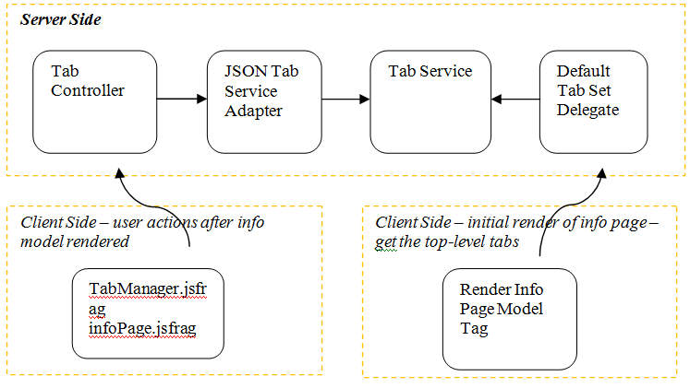

The tabs that a user sees an information page are thus a combination of the actions defined by the actions model XML, any tabs created by the site administrator, any tabs created by the organization administrator, and any tabs created by the user. It is important to note that information tabs are linked to an object type. That is, if “Tab A” is created for a document, then “Tab A” will be seen on every document information page, but not on information pages for other object types (i.e. Part).
The default implementation of the TabSetDelegate follows the following algorithm for determining what tabs to display for a given information page:
• Retrieve the tabs defined by the action model
• Retrieve the tabs defined by the site administrator for the object type
• Retrieve the tabs defined by the user’s organization administrator for the object type
• Retrieve the tabs defined by the user for the object type

Customization Points
This section contains the following topics:
• Customizing Tabs via Windchill UI
• Customizing Tabs by Implementing Custom TabSetDelegate
• Customizing Tabs by Implementing Custom TabController

Customizing Tabs via Windchill UI
This section contains the following topics:
• General Procedure
• Out-of-the-Box (OOTB) Tabs
• Customizing Tabs — Site Administrator
• Customizing Tabs — Organization Administrator
• Customizing Tabs — Standard User
• Reordering Tab Content Items

General Procedure

Users can create and configure a tab by visiting an information page for the type you wish to configure. Click the tab with the “+” icon to create a new tab, and configure the tab as needed.
It is important to note that throughout this process the tab is being saved, without any explicit action required. The very act of creating a new tab creates a new tab object in the database. Any actions to the tab, including changing its name, adding content, or deleting it, are immediately saved on the server.
The general procedure for adding and configuring a tab for a specific type is illustrated below. In this example, we will create and configure a tab that will display history information for documents:

- Visit the information page of any document, and create a new tab by clicking the “+” tab:
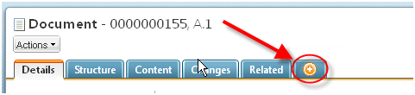

- This will create a new tab, named “New Tab 1” (or “New Tab 2” or some variation, depending on how many newly created tabs there are):
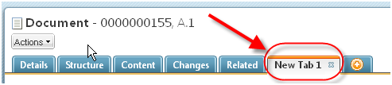

- You can than rename this tab to something more meaningful. In this case, since this tab will be used to display history information, we will rename it to “History” by right-clicking on the tab itself, and invoking the Rename Tab action:
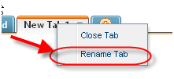

- Enter the desired name into the resulting dialog, and you should see the tab’s new name:


There is a OOTB tab named History. This example assumes that you have hidden the OOTB History tab by commenting out <subModel name=?docObjectHistoryTab?/> in the <Windchill>/codebase/config/actions/DocumentManagement-actionmodels.xml file.
- New tabs are initially added to the right most end of the tab set. You can move your new tab to a different position in the tab set using a left-mouse click and drag-and-drop:


The order set for custom or configured tabs is not retained after an upgrade.

- At this point, we have created a tab, given it a descriptive name, and moved it to the desired position in the tab set. We have yet to add any content to it, however, so it is not very useful yet. We’ll add content to the tab by clicking the “Customize” link. The Customize menu shows the content items that can be added to the tab. Content items are typically tables or attribute panels. The main Customize menu shows categories of content items. Each category has a submenu showing the content items in that category. You can select all the content items in a category by checking the box associated with the category or you can select individual content items within a category. We’ll add the “Version” table to our new tab by selecting it in the Customize menu:
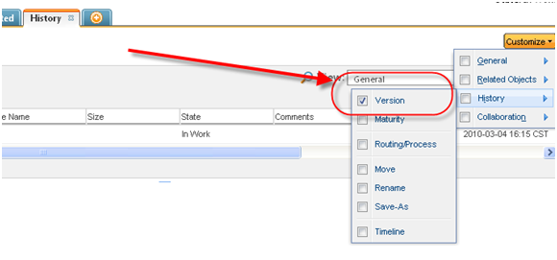

7. Now we have a History tab, with the Version component added to it. Depending on the administrative role of the user performing this action, this tab and its content will either be unique to the user, available for all users within the organization, or available for all users within the site, for all documents. This is explained in the following sections.
In order to delete any user created tab, you can delete by right clicking on the tab itself and invoking “Close Tab” action.

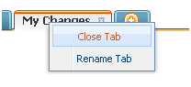

- You will get below confirmation dialog, by clicking OK, the tab will get deleted and by clicking Cancel you will be returned to the page.
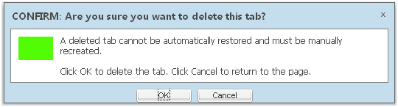

- The tab can also be deleted by clicking “x” on the tab itself.


Out-of-the-Box (OOTB) Tabs

A set of tabs can be configured out-of-the-box. These tabs are configured in an actionModels.xml file, like this:
<model name=”partInfoPageTabSet” resource=”com.ptc.core.ui.navigationRB”>
<submodel name=”partInfoDefaultDetails” type=”object”/>
<action name=”productStructureGWT” type=”psb”/>
</model>
The model can contain the following elements:
• submodel : specifies the tab name (display name mapped to the name of the submodel) and the items (tables) to render on the tab. Each action defined within the submodel, a corresponding item (table) is rendered to the body of the tab.
• action : specifies the tab name (display name mapped to the name of the action) and the component or JSP to include as the tab body. The HTML returned from the action is rendered as the body of the tab.
The action model is set in the component builder for the given component. Please refer to Sample Code for usages of Client Tabs for a specific component.
Out-of-the-box tabs can only be modified by changing the action definition in the XML file. Users (site administrator, organization administrator, or standard users) are not allowed to change the name of the tab, change the contents of the tab, or remove the tab.
All users will have the ability to change the order in which the tabs appear, this includes out-of-the-box tabs.

Customizing Tabs — Site Administrator

A site administrator can create and configure tabs, per object type, that will be available for all users in that site. If the site administrator creates a History tab, for example, as detailed in General Procedure, that tab will be seen on all document information pages, for all users in the site. The site administrator will not see all the tabs for all of the organizations. They will just see what tabs are at the site level.
Tabs created by a site administrator, can only be managed by a site administrator. That is, only a site administrator can change the name of the tab, can change the contents (including the ordering of the contents) of the tab , can make it Public so that all the users in the system can see it, or remove the tab.
All users will have the ability to change the order in which the tabs appear, this includes out-of-the-box tabs and tabs created by a site administrator.
By default, the tabs created by a Site Administrator will be private tabs and are not seen by any other users. The tab can be made public by invoking the “Set Public” tab action. At this point all the users in the system can see this tab and its content. Notice that the color of the tab changes and an icon appears next to the customize menu to indicate that the tab is public.
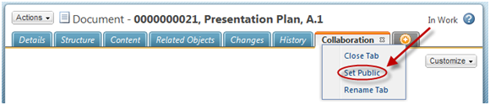

A public tab can be made private by invoking “Set Private” tab action. Making a public tab private will remove the tab for all other users, this could be confusing to the users.

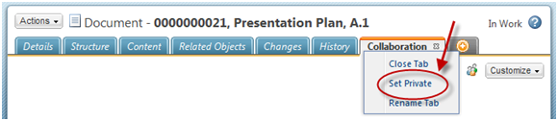

Customizing Tabs — Organization Administrator
An organization administrator can create and configure tabs, per object type, that will be available for all users in that organization. If the organization administrator creates a History tab, for example, as illustrated in General Procedure, that tab will be seen on all document information pages, for all users in that organization.
Tabs created by an organization administrator, can only be managed by an organization administrator. That is, only an organization administrator can change the name of the tab, can change the contents (including the ordering of the contents) of the tab, can make it Public so that all the users in that organization can see it, or remove the tab.
A site administrator will not be able to manage a tab created by an organization administrator.
All users will have the ability to change the order in which the tabs appear, this includes out-of-the-box tabs and tabs created by an organization or site administrator.
By default the tabs created by an Organization Administrator will be private tabs and are not seen by any other users in that organization. The tab can be made public by invoking the “Set Public” tab action. At this point all the users in that organization can see this tab and its content. Notice that the color of the tab changes and an icon appears next to the customize menu to indicate that the tab is public.
A public tab can be made private by invoking “Set Private” tab action. Making a public tab private will remove the tab for all the users of that organization; this could be confusing to the users.

Customizing Tabs — Standard User

A standard user can also create and configure tabs, per object type, that will be available for only that user. If the user creates a History tab, for example, as illustrated in General Procedure, that tab will be seen on all document information pages, for only that user.
Tabs created by a standard user, can only be managed and seen by that user. That is, only that user can change the name of the tab, can change the contents (including the ordering of the contents) of the tab, or remove the tab. Standard users do not see the Set Public/Set Private tab actions. These actions are limited to Site and Organization administrators.
A site administrator or organization administrator will not be able to manage a tab created by a standard user.
All users will have the ability to change the order in which the tabs appear, this includes out-of-the-box tabs and tabs created by administrators.

Reordering Tab Content Items

If a tab contains more than one content item, the content items may be reordered using the Table of Contents links on the tab. Left-click on a content item link and drag-and-drop the link to the position corresponding to where you want the item to appear on the tab:

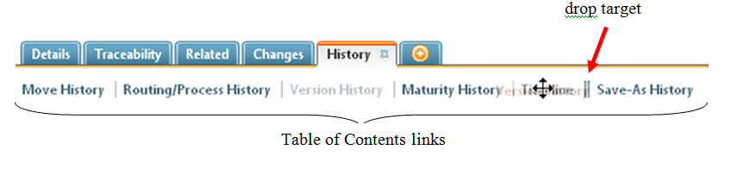

As stated earlier, administrators can only reorder the contents of tabs created by administrators and users can only reorder the contents of tabs they created. If you do not have the ability to modify the order of the contents, the content items will not be displayed as links in the Table of Contents.

Customizing Tabs by Implementing Custom TabSetDelegate

It is possible to control a different algorithm for displaying the tabs. The TabSetDelegate class is what brings together tabs from the *actions.xml and tabs that are stored in the database. The RenderInfoPageModelTag will take the output from the TabSetDelegate.getDefaultAndDynamicTabs() and render out JSON that will display the tabs on the client. The code could look something similar to the following:
public class DefaultTabSetDelegate implements TabSetDelegate {
/**
* This is the main method to add the site, org and user tabs along side
* the default set that was in the action model.
*/
public NmHTMLActionModel getDefaultAndDynamicTabs() {…code here}
To add your own TabSetDelegate class you can specify the following in the service.properties file:
<Service context="default" name="com.ptc.core.ui.tab.TabSetDelegate">
<Option serviceClass="com.ptc.core.ui.tab.your.package.
CustomizedClassDelegate"
requestor="infoPage" selector="wt.part.WTPart"/>
</Service>
The selector is specified for the type of wt.part.WTPart. This means that the delegate will be called for part information pages and all soft types of WTPart.

Customizing Tabs by Implementing Custom TabController

Ajax requests are sent to the TabController in order to have the information persisted into the database. This can be customized by extending or creating a new controller with a request mapping that would be similar to the following example code:
@Controller
@RequestMapping(value = "/tab/**")
public class MyTabController {
/**
* Creates, Updates, or deletes the tab by calling the @link
{JSONTabServiceAdapter}.
*
* @param data - String version of the JSON object
* @param action - will be set to one of the following values:
[create, update, delete]
* @param request
* @param response
* @throws IOException
*/
@RequestMapping(method = { RequestMethod.POST, RequestMethod.PUT })
protected void createAndUpdateTab(@RequestParam("data") final String data,
@RequestParam("action") final String action,
HttpServletRequest request,
HttpServletResponse response) throws IOException {…code here…}

Exporting and Importing Client Tabs
Exporting
You can export client tabs using a command line application.
1. From the Windchill shell, enter: java com.ptc.core.ui.ixb.ClientTabExport tabname
The required tabname parameter is the name of the tab to export.
◦ For a home page, this should be the string homepage.
◦ For other tabs, the name is that shown on the tab in the UI.
◦ To export a tab that includes spaces in the name, double-quote the parameter: “My Custom Tab”.
2. You will be prompted for a Windchill user name and password. Enter the Site Administrator’s credentials.
3. Wildcards are added internally; the resulting query is: select * from CLIENTTAB where NAME like %tabname%;
4. The export utility reports the names of exported tabs, and the location of the .jar file it produces:
> java com.ptc.core.ui.ixb.ClientTabExport a
2011-10-14 09:55:38,377 INFO [main] com.ptc.core.ui.ixb.ClientTabExport
- Exporting tab OrgAttr
2011-10-14 09:55:38,393 INFO [main] com.ptc.core.ui.ixb.ClientTabExport
- Exporting tab my custom tab
2011-10-14 09:55:38,393 INFO [main] com.ptc.core.ui.ixb.ClientTabExport
- Exporting tab jcrpage
2011-10-14 09:55:38,393 INFO [main] com.ptc.core.ui.ixb.ClientTabExport
- Exporting tab homepage
2011-10-14 09:55:40,127 INFO [main] com.ptc.core.ui.ixb.ClientTabExport
- Exported to <WT_HOME>\Windchill\temp\IXBExpImp\1279724139377-1977404926\Export5586892419340327596.jar

Importing
Importing ClientTab records is performed from the WindchillImport/Export Management utility.
1. Log into Windchill on the destination system as the Site Administrator.
2. From the Site > Utilities > System Administration > Import/Export Management.
3. The WindchillImport/Export Management utility presents an option to import or export.
4. Choose Import. In the import dialog box, paste or browse to the path of the exported .jar file.
If the container or user of an imported tab (whichever applies) is not present on the destination system, that tab is not imported. A warning will be displayed.

Sample Code

Packaged Samples
There is a carambola information page underCustomization > Example > Information Page.
http://<machineNam>/<webApp>/app/#ptc1/tcomp/infoPage?typeIdForTypeLookup=com.ptc.carambola.customization.examples.infoPage.Carambola

Checkin/Checkout

Objective
You want to be able to checkin and checkout an object.
Background
The ability to check in and checkout gives the ability to track changes to an object by providing an iteration history of each change. Also if a user has an object checked out, no other user may modify the object until it has been checked back in.
In order for an object to work with the checkin/checkout common component it must implement the wt.vc.wip.Workable interface.
Scope/Applicability/Assumptions
• The object implements either the Workable interface.
• Familiarity with the actions framework
• Familiarity with the basic concepts of checkin/checkout

Intended Outcome
By following these procedures you should be able to add or modify the checkin and checkout actions.
• Checkout action (no wizard involved)
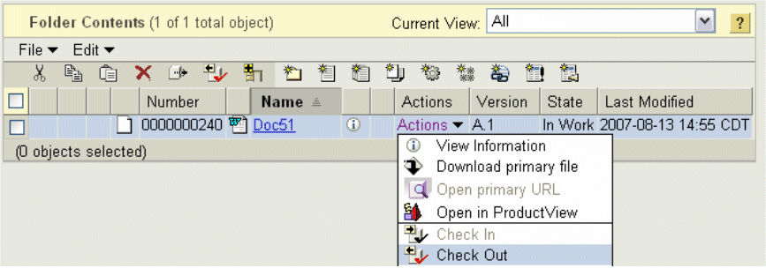
• Checkout status icon after the object is checked out
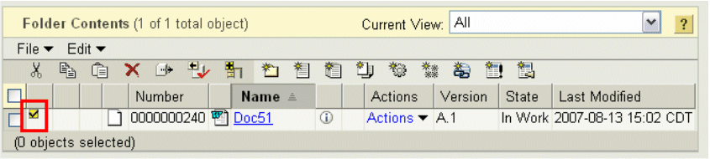

• Checkin wizard (in this case with primary content but the primary attachment component will not appear if your object does not support it).
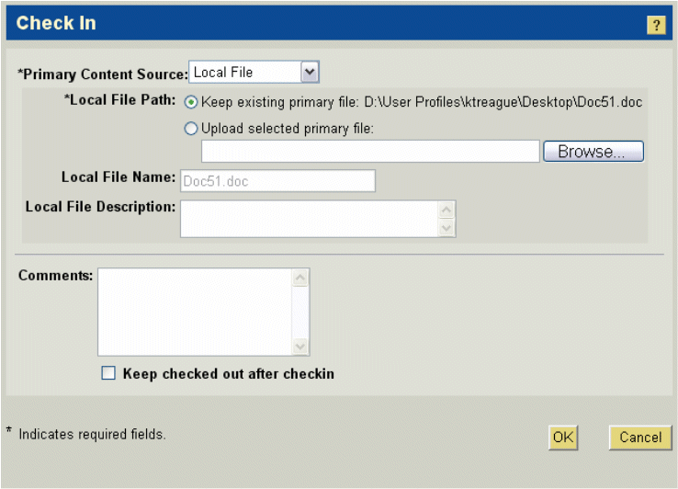

Solution
Use the Checkin/Checkout common components with your object.
Prerequisite knowledge
To achieve this objective, you need to have an understanding of the following:
• Windchill “work in progress” checkin/checkout concepts.
• The actions framework in the Windchill client architecture.
• Basic development involving HTML forms, JSP, and XML.
Procedure – Adding checkin/checkout actions to a business object
In the action model xml file that defines the action model with the menufor attribute for your object type add the following actions. This will provide checkin, checkout, checkout & download, undo checkout, replace content, and checkout & edit actions for your object. Note, only add checkout & download and replace content actions if you are adding these actions for an object that implements the FormatContentHolder interface and you expect it may have primary content.
<action name="checkin" type="wip"/>
<action name="checkout" type="object"/>
<action name="checkout_and_download" type="wip"/>
<action name="undocheckout" type="object"/>
<action name="replace_content" type="wip"/>
<action name=" checkoutAndEdit " type="YOUR TYPE FROM YOUR TYPE’S
ACTIONS XML"/>
Checkout and edit however requires additional coding. Create an additional action definition in the actions.xml file for your object type. Name the action “checkoutAndEdit” so that the validation framework will pick it up properly. Then set the url attribute to point to your wizards edit jsp file.
Example:
<action name="checkoutAndEdit">
<command
class="com.ptc.core.components.forms.EditWorkableFormProcessor"
method="execute" url="netmarkets/jsp/document/edit.jsp"
windowType="popup" /
</action>
Add the appropriate entries for this action in your rbinfo file (see actions framework documentation). In your edit jsp file you will need to add the following tag above the wizard declaration.
<%@ taglib prefix="wip"
uri="http://www.ptc.com/windchill/taglib/workinprogress"%>
<wip:autoCheckOutItem />
This will allow the wizard to checkout the object if the object is not already checked out.
Using this tag on wizards other than edit or without a processor that is extending EditWorkableFormProcessor is not supported and may result in unstable code.

Examples of Usage in Windchill Code
To view a sample action model with checkin/checkout actions see the document action models (<Windchill>\codebase\config\actions\DocumentManagement-actionmodels.xml)
To view a sample checkout and edit action see the action definition in the document actions definitions (<Windchill> \codebase\netmarkets\jsp\document\edit.jsp) and the document edit JSP file (<Windchill>\codebase\config\actions\DocumentManagement-actions.xml)

Component Access Control

Intended Outcome
The feature may be used in two ways:
• The Edit Access Control action can be added to the object’s action model and the action will be available in the object’s action list.
The visibility of the action may be constrained by profiles defined in the Role Based UI. See Managing Profiles for more details about profile- and role-based visibility administration.

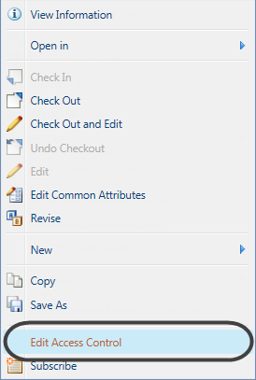

• The Access Control Component can be included as a step in the object’s Create wizard. It appears as an optional Set Access Control step in the create process, which is highlighted in the wizard at this point.

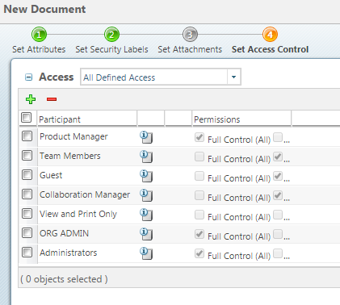

Solution

Solution Elements

Element | Type | Description
actionmodels.xml | XML | <Windchill>\codebase\actionmodels.xml  The actionmodels file defines the actions available in named action models.
Create<myObject>.jsp | JSP | The outer jsp file defining a create wizard

Procedure - Adding an Edit Access Control action to an action model
Include the following in the desired action model in your object's actionmodels.xml:
<action name="ManageSecurity"
type="accessPermission"/>

Procedure - Including an Access Control Step in a Create Wizard
Update the main Create<myObject>.jsp to define the JCA tag library:
<%@ taglib prefix="jca"
uri="http://www.ptc.com/windchill/taglib/components" %>
Include the access control wizard step:
<jca:wizardStep action="setAccessControlWizStep" type="object"/>

Customization Points

Configuring the access permissions
The permissions presented for view and update in the common access control component are configurable at the site, org, and application container with the preference service. At each container level, administrators can select the permissions that members of the container will be permitted to view and potentially update.
The initial values for the permission configurations are loaded from <Windchill>\loadFiles\preference.foundation.xml with a csvcategoryName of “SECURITY_PERMISSION_CATEGORY”.
Below is an example loading the initial system configuration for the Read permission.
<csvPreferenceDefinition
handler="wt.preference.LoadPreference.createPreferenceDefinition">
<csvname>security/accessPermissionRead</csvname>
<csvvisibility>HIDDEN</csvvisibility>
<csvcategoryName>SECURITY_PERMISSION_CATEGORY</csvcategoryName>
<csvdisplayName>com.ptc.core.security.securityResource:READ</csvdisplay
Name>
<csvdescription>com.ptc.core.security.securityResource:READ</csvdescript
ion>
<csvlongDescription>com.ptc.core.security.securityResource:READ</csvlong
Description>
<csvdefaultValue>UPDATE</csvdefaultValue>
<csvhandler>com.ptc.windchill.enterprise.preference.handler.ChoiceMultiPr
eferenceValue
Handler:readPermission:HIDE,com.ptc.core.security.securityResource,HIDE:V
IEW,com.ptc.
core.security.securityResource,VIEW:UPDATE,com.ptc.core.security.security
Resource,
UPDATE</csvhandler>
</csvPreferenceDefinition>
<csvLinkPreferenceClientDefinition
handler="wt.preference.LoadPreference.setClientDefinitionLink">
<csvname>security/accessPermissionRead</csvname>
<csvclientName>WINDCHILL</csvclientName>
</csvLinkPreferenceClientDefinition>

Configuring the access permissions
The initial state of the permission configuration can be modified by changing the “csvdefaultValue” for the permission entry. The possible values are “HIDE”, “READ”, and “UPDATE”.

Sample Code

Examples of usage in OOTB code
Edit Access Control Action in document action model
Edit Access Control is an action available in the action list on a document info page. The action is included in the “docs details page actions” action model defined in <Windchill>\codebase\actionmodels.xml
<!-- list used on document details page -->
<model name="docs details page actions">
<action name="oldedit" type="document"/>
<action name="download" type="document"/>
<action name="route" type="workflow"/>
<action name="setState" type="lifecycle"/>
<action name="createSubscription" type="subscription"/>
<action name="checkout" type="object"/>
<action name="checkin" type="document"/>
<action name="undocheckout" type="object"/>
<action name="rollupIterations" type="object"/>
<action name="update" type="document"/>
<action name="rename" type="document"/>
<action name="ManageSecurity" type="accessPermission"/>
<action name="delete" type="object"/>
<action name="bookmarkIt" type="bookmark"/>
<action name="create_deli" type="deliverable"/>
<action name="cut" type="object"/>
<action name="copy" type="object"/>
<action name="export" type="object"/>
<action name="viewInProductView" type="document"/>
<action name="pdmCheckInApply" type="object"/>
<action name="SBSendToPdm" type="sandbox"/>
<action name="sandboxUndoCheckoutDetails" type="object"/>
<action name="removeShare" type="object"/>
<action name="EDA_COMPARE" type="EDAcompare"/>
<action name="VALIDATION_MANAGER" type="EDAcompare"/>
<action name="SETUP_FILE" type="EDAcompare"/>
<action name="wtObjCompare" type="ocmp"/>
</model>

Access Control Step in Create Document Wizard
The Create Document wizard is an example of Access Control as a step in a create wizard.
Source file: wcEnterprise\DocumentManagement\src_web\netmarkets\jsp\document\create.jsp
<%@ taglib prefix="jca"
uri="http://www.ptc.com/windchill/taglib/components" %>
<%@ taglib prefix="docmgnt"
uri="http://www.ptc.com/windchill/taglib/docmgnt" %>
<%@ include file="/netmarkets/jsp/components/beginWizard.jspf"%>
<%@ include
file="/netmarkets/jsp/components/includeWizBean.jspf"%>
<jca:initializeItem operation="${createBean.create}"/>
<docmgnt:validateNameJSTag/>
<jca:wizard title="${param.titleString}">
<jca:wizardStep action="setContextWizStep" type="object"/>
<jca:wizardStep action="defineItemWizStep" type="object"/>
<jca:wizardStep action="setAttributesWizStep" type="object"
/>
<jca:wizardStep action="attachments_step" type="attachments"
/>
<jca:wizardStep action="setAccessControlWizStep"
type="object"/>
</jca:wizard>
<jca:action actionName="fileSelectionAndUploadApplet"
actionType="attachments" />
<script type="text/javascript">
setUserSubmitFunction(submitFileContent);
</script>
<%@ include file="/netmarkets/jsp/util/end.jspf"%>
The definition of “setAccessControlWizStep” is in Source file, <Windchill>\codebase\config\actions\Security-actions.xml, which defines :
<action name="setAccessControlWizStep"
id="setAccessControlWizStep" preloadWizardPage="false">
<command
class="com.ptc.core.security.forms.UpdatePermissionsFormDelegate" method=""
windowType="wizard_step"/>
</action>

Attachments

Background
Object types such as documents implement an interface called FormatContentHolder which allows them to associate one piece of content as “primary content”. There can only be one primary content though.

Object types such as a change requests implement ContentHolder which allow them to have multiple secondary content but not primary attachments.

Objects that implement FormatContentHolder however can have both primary and secondary attachments because FormatContentHolder is a specialization of the ContentHolder interface.

Intended Outcome

By following these procedures you should be able to add or modify the following components to your UI.
Primary content component in a wizard (object must be a FormatContentHolder)
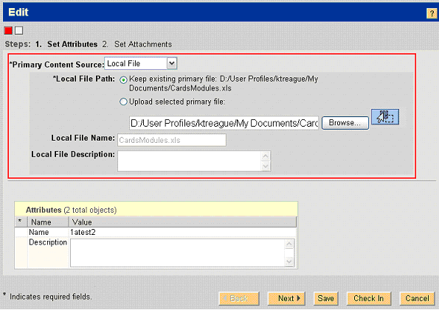

Secondary attachments component in a wizard (object must be a ContentHolder)
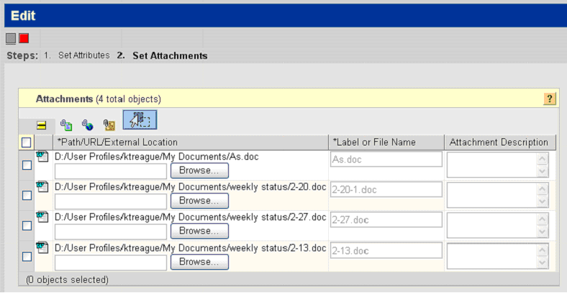

Attachments table in a details page (object must be a ContentHolder)

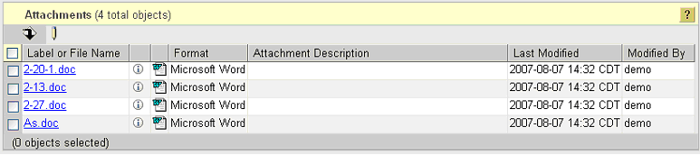

Primary content component in an info page properties panel (object must be a FormatContentHolder)

Primary content component in an info page properties panel (object must be a FormatContentHolder)

Solution

Solution Elements
Element | Type | Description
attachments.tld | Java tag definition | Defines any common component tags you will need to use the attachments common components.  Runtime location:  codebase\WEB-INF\tlds\ attachments.tld
AttachmentsDownload AppletServlet.class | Java file | Servlet that redirects download to the appropriate file for the object.  Runtime location:  codebase\WEB-INF\lib\ wncWeb.jar
AttachmentsValidation Helper.class | Java file | Supporting methods for validating various attachments related actions.  Runtime location:  codebase\WEB-INF\lib\ wncWeb.jar
AbstractAttachments SubFormProcessor.class | Java file | General form processing delegate that provides shared attachments functionality to the primary and secondary form processors.  Runtime location:  codebase\WEB-INF\lib\ wncWeb.jar
PrimayAttachment SubFormProcessor.class | Java file | Form processing delegate that attaches primary attachments to the object.  Runtime location:  codebase\WEB-INF\lib\ wncWeb.jar
SecondaryAttachments SubFormProcessor.class | Java file | Form processing delegate that attaches secondary attachments to the object.  Runtime location:  codebase\WEB-INF\lib\ wncWeb.jar
AttachmentsDataUtility Helper.class | Java file | Supporting methods for displaying attachments data in a data utility.  Runtime location:  codebase\WEB-INF\lib\ wncWeb.jar

Procedures
• Adding primary content to a wizard
To add primary attachment support to a wizard of an object that implements the FormatContentHolder interface you will need to add the applet tag to the main wizard jsp and the primary attachment tag to a wizard step.
On the main wizard jsp (which defines the <jca:wizard tag and the wizard steps) add the following tag definition and fileSelectionAndUploadApplet tag. The tag will render a tiny invisible applet which is used for file browsing and file uploading.
<%@taglib prefix="attachments"
uri="http://www.ptc.com/windchill/taglib/attachments" %>
<attachments:fileSelectionAndUploadApplet/>v
On the wizard step you will need to add the same taglib definition above (but not the applet tag) and the following tag. This tag will render the actual primary attachment input components such as the file chooser or the url inputs.
<attachments:primaryAttachment/>
• Adding secondary attachments to a wizard
To add secondary attachment support to a wizard of an object that implements the ContentHolder interface you will need to add the applet tag to the main wizard jsp and the attachments wizard step.
On the main wizard jsp (which defines the <jca:wizard tag and the wizard steps) add the following tag definition and fileSelectionAndUploadApplet tag. The tag will render a tiny applet which is used for file browsing and file uploading.
<%@taglib prefix="attachments"
uri="http://www.ptc.com/windchill/taglib/attachments" %>
<attachments:fileSelectionAndUploadApplet/>
Inside your wizard definition (inside the <jca:wizard tags) add the following wizard step in the order that you would like it to appear.
<jca:wizardStep action="attachments_step" type="attachments" />
Attachments are not supported in Change Task wizards.

• Adding primary attachments to an info page
On your info page jsp you will need to add the following inside the describePropertyPanel tags to get the primary attachment info and download icon included in the info page attributes.
<jca:describeProperty id="primaryAttachmentProperties" label="${primaryLabel}"/>
To get it on the additional attributes info page add this to your object's attributes.jsp
<jsp:include
page="/netmarkets/jsp/attachments/attachments_table.jsp"
flush="true">
<jsp:param name="role" value="PRIMARY" />
</jsp:include>
• Adding secondary attachments to an info page
On your object's attributes.jsp add the following to get the secondary attachments to show up under the more attributes sub navigation of the info page.
<jsp:include
page="/netmarkets/jsp/attachments/attachments_table.jsp"
flush="true">
<jsp:param name="role" value="SECONDARY" />
</jsp:include>
• Adding Primary attachment actions to an object
In the action model xml file that defines the action model with the menufor attribute for your object type add the following actions. This will provide download or url redirect actions depending on if the object has a primary file or url.
<action name="download_primary_attachment"
type="attachments"/>
<action name="redirect_primary_attachment"
type="attachments"/>
<action name="checkout_and_download" type="wip"/>
<action name="replace_content" type="wip"/>

Customization Points

<primaryAttachment> tag attributes
Parameter | Default Value | Possible Values | Req? | Description
allowFile | true | True/False | no | Allows the Local File option to be displayed.
allowUrl | true | True/False | no | Allows the URL Link option to be displayed.
allowExternal | true | True/False | no | Allows the External Storage option to be displayed.
fixedFilePath | null | Valid file path | no | Renders the file path specified instead of allowing the user to choose the file. If fixedFileUpload param on this tag and the forceApplet param on the fileSelectionAndUpload Applet tag are both set this can be used to force the specified file to be uploaded and attached to the object.
forceApplet | False | True/False | no | Determines if we should force the applet to be rendered regardless of the upload mechanism preference

How to hide primary content for an object
In order to hide primary content for an object you will need to do the reverse of the above five procedural steps by removing those entries from the wizards, jsp’s, and the action model. You will also need to modify \codebase\netmarkets\jsp\wip\checkin_step.jsp and remove the if block for FormatContentHolder with the page include for the FormatContentHolder page (leave the “getRespectiveNonFormatContentHolderPage” include there).

Additional notes about documents:
For documents only (not other FormatContentHolders) you will find similar entries in the wizard jsp’s but they may slightly vary by referring to an MSOI tag which extends the attachments tags. Removing these tags will remove primary attachments from documents but it will also render desktop integration useless since desktop integration depends on having file primary attachments. You will also need to remove the createMulti action from all action models since it depends on primary content.

How to remove url & external data options
On the primaryAttachment tag you may set the allowUrl and allowExternal attributes to false. In the event that you wish to disable url and external data options for documents only you can modify the following file.
codebase\WEB-INF\tags\primaryAttachmentWithMSOI.tag

Limitations

Primary content
For primary attachments code to function properly you need both the primaryAttachment tag as well as the fileSelectionAndUploadApplet tag, regardless of whether or not you are using applet upload. While some behavior can be controlled by custom code we highly recommend that you first try adjusting the site level preferences and tag attributes to accomplish your goal before customizing your code.
The fileSelectionAndUploadApplet tag must be on the jsp that defines the wizard but outside of the wizard tags or it will not function properly.
Secondary content
For secondary attachments code to function properly you need attachments step defined in your wizard as well as the fileSelectionAndUploadApplet tag, regardless of whether or not you are using applet upload. The fileSelectionAndUploadApplet tag must be on the jsp that defines the wizard but outside of the wizard tags or it will not function properly.

Sample Code

Examples of Usage in Windchill Code
• Secondary attachments
Excerpt from the create change request wizard (<Windchill>\codebase\ netmarkets\jsp\changeRequest\create.jsp).
...
%><%@taglib prefix="attachments"
uri="http://www.ptc.com/windchill/taglib/attachments"
...
<jca:wizard helpSelectorKey="change_createChangeRequest"
buttonList="DefaultWizardButtonsWithSubmitPrompt"
formProcessorController="com.ptc.windchill.enterprise.change2.form
s.controllers.ChangeRequestFormProcessorController">
...
<jca:wizardStep action="attachments_step" type="attachments"
/>
...
</jca:wizard>
<attachments:fileSelectionAndUploadApplet/>
<%@ include file="/netmarkets/jsp/util/end.jspf"%>
• Primary attachments
Wizard JSP
<%@taglib prefix="attachments"
uri="http://www.ptc.com/windchill/taglib/attachments" %>
...
<jca:wizard buttonList="DefaultWizardButtonsWithSubmitPrompt">
...
<jca:wizardStep action="attributes_step" type="attachments"
/>
...
</jca:wizard>
.<attachments:fileSelectionAndUploadApplet/>
...
Attributes Step JSP
<%@taglib prefix="attachments"
uri="http://www.ptc.com/windchill/taglib/attachments" %>
...
<attachments:primaryAttachment>
...

Attribute Panels
You want to display attributes of a Windchill object in a name: value format. The attribute values could be read-only or editable.
The practices described in this section should be used when you want to display attributes of a single Windchill object for viewing or editing. The attribute panel object may or may not be TypeManaged, however to configure the panel from a layout it must be TypeManaged.

Intended Outcome
After reading this document you should be able to create simple and advanced attribute panels in either edit or view mode. Specifically, you will learn how to:
• Create advanced attribute panels using Type Management layouts
• Create simple and advanced attributes panels by manually configuring the panels in a Java builder class
• Create simple attribute panels using JSP tags
• Include your panel in a JSP page
• Convert custom attribute panels/tables created in Windchill Release 9.0 or later to Windchill Release 10.0 attribute panels

Background

Windchill provides an attribute panel component that can be used to display attributes of a Windchill object. Typically, these are used to display attributes in read-only mode on object info pages or in edit mode in wizards. Attribute panels can be configured to be a simple list of name:value pairs or they can be configured to have a more complex layout with:
• A border
• Attribute groups, each with a title and expand-collapse capability
• Multiple columns
The former will be referred to in this document as “simple attribute panels” and the latter as “advanced attribute panels.”

Attribute Panel Examples
This is an example of a simple view-only attribute panel:
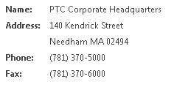

This is an example of a simple editable attribute panel:
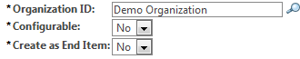

This is an example of an advanced view-only attribute panel with two groups and multiple columns in each group:
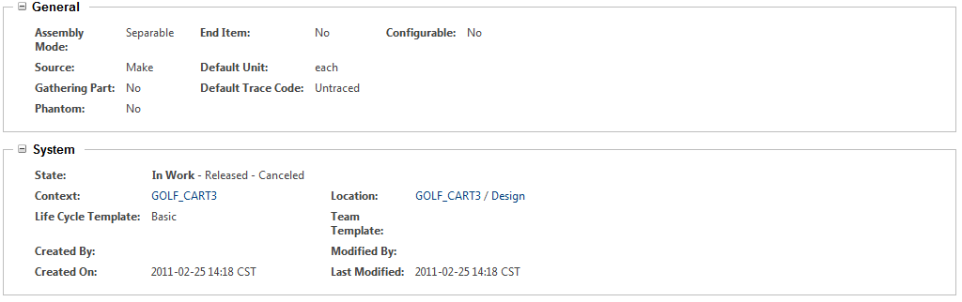
This is an example of an editable advanced attribute panel with a single group and one column:
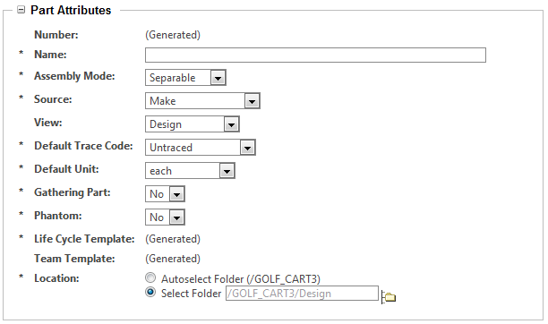

The advanced panel layout features are new for Windchill Release 10.0. Previously, only simple attribute panels, formerly called property panels, were used:
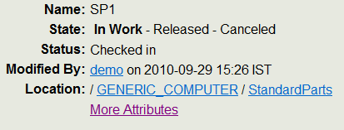
Also, prior to Windchill Release 10.0, object attributes were sometimes displayed in table format rather than in panels:
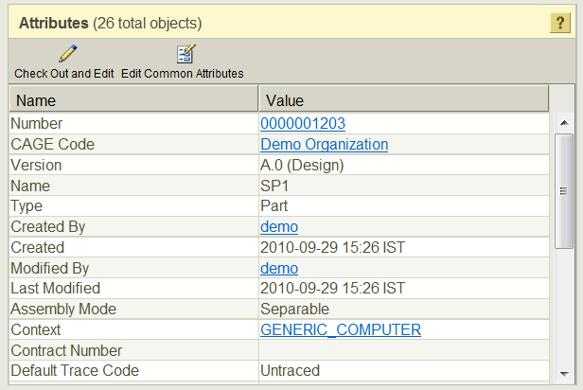

The attribute table format is no longer used in Windchill 10.0, although customizations using the attribute table component will continue to work.

Definition of Terms

Definition of terms used in this section.
Term | Definition
simple attribute panel | A single-column list of attribute name: value pairs
advanced attribute panel | Attribute name:value pairs contained in one or more groups, each with a title and an example-collapse feature. Groups may have multiple columns of attribute pairs. A border surrounds the entire panel.
context object | The context object for a panel, typically derived from a URL parameter such as “oid”
datum object | The object that is passed to the data utilities that create the data model for the panel. The datum is created by the buildComponentData() method of builder classes. Also sometimes called “row object.” See NmObject Utilities for more information.
target object | May be used when the datum for the panel is a composite object. The target object specifies the specific member of the datum object that should be used for the panel or attribute within the panel. For example, if your datum was a WTPartUsageLink, you could specify a target object of RoleAObject.  The target object must be addressable from the datum object.  See NmObject Utilities for more information.

Solutions

Overview

Both simple and advanced attribute panels can be created using Java builder classes. Simple attribute panels can also be created using only JSP tags in certain limited cases. When a builder class is used to create a panel for a TypeManaged object, the contents and configuration of the panel can be defined in a layout in the Type and Attribute Management utility and retrieved by the builder class. Alternatively, the contents and configuration of the panel can also be defined in the builder itself. The recommended approach is to:
• Use a layout-based based panel created by a Java builder whenever possible. This provides:
◦ easier customization
◦ a UI for ease of configuration
◦ greater reusability
◦ a more consistent product
• Use a non-layout based panel created by a Java builder if:
◦ The object type being displayed is not TypeManaged or
◦ The type is TypeManaged but layouts are already defined for all related screen types and none are appropriate for your purpose
• Use a JSP-tag based panel only if:
◦ You want to create a simple attributes panel and
◦ You only want to display a few attributes which do not require complex configurations and
◦ You don’t want the overhead of creating a builder class
Action Name | Action Object Type | Component Builder ID | Description
visualizationAndAttributes | object | ComponentId.VIS_AND_ATTRIBUTES | Used to display the “Visualization and Attributes” panel on information pages
primaryAttrbutes | object | ComponentId.PRIMARY_ATTRIBUTES | Used to display the “Attributes” panel on information pages of object types that have no visualization component
attributes | object | ComponentId.ATTRIBUTES_ID | Used to display the “More Attributes” panel on information pages

To display these panels you just specify the appropriate component builder id in the URL or action used to generate the panel on your page. You do not need to write any Java code or JSPs. The system also provides OOTB builders for the layout-based “Attributes” panels in object create and edit wizards that can be displayed by using the common step actions for wizards.
To display a panel for a different layout or create a manually-configured panel you can extend an existing Java builder class.
The decision diagram below provides general guidelines for how you should determine which builder to use for your panel, with references to the section of this document that describes the builder.
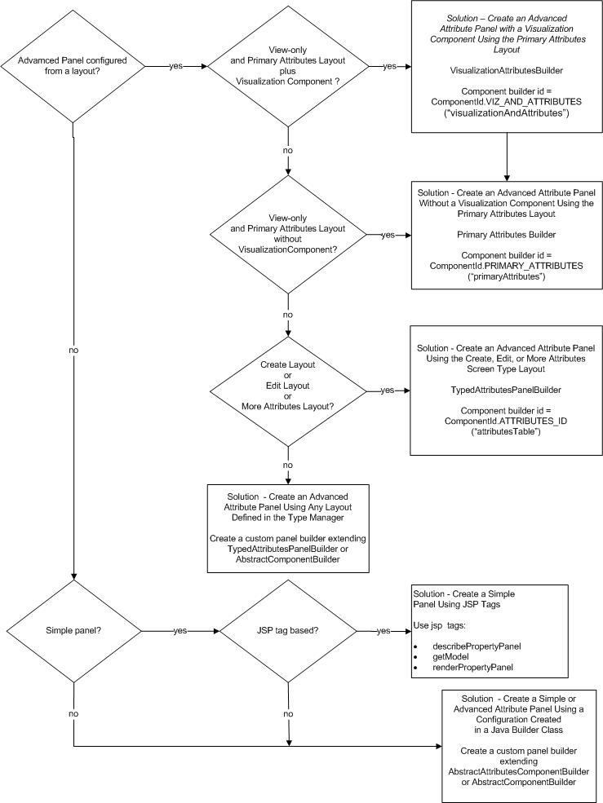

Solution Elements

Element | Type | Description
Type and Attribute Management utility | Application | The application where you can:  • Define attributes on a type  • Define attribute layouts  • Configure the display properties of an attribute  See Type and Attribute Management for more information about this utility.
MVC Builder | Java class | Creates the configuration and datum object for the panel. Also can be used to specify the view (JSP) for the panel if a custom view is desired.
AttributePanelConfig | Java class | The object that contains theGroupConfig(s) for an attribute panel. Also has several properties that can be used to configure the panel.
GroupConfig | Java class | The object that contains the AttributeConfig(s) for an attribute panel. Also has several properties that can be used to configure the group.
AttributeConfig | Java class | Contains information about one attribute to be displayed in the panel, including its name and properties that control how the attribute should be displayed.
ComponentConfigFactory | Java class | A factory that generates AttributePanelConfigs, GroupConfigs, and AttributeConfigs
TypedAttrLayOutFactory | Java class | A factory capable of generating an attribute panel configuration from a Type Management layout for a given object type and screen type
ScreenDefinitionName | Java enum | Identifiers for the screen types shown in the Type and Attribute Management utility Layouts tab. For a given object type each screen type maps to one layout. However, a layout may map to more than one screen type.
ComponentId | Java class | Contains constants for some widely used component builder ids.
ComponentMode | Java enum | Determines whether view-only or input fields are displayed for attributes.
ComponentType | Java enum | Indicates how the attribute panel is being used. The ComponentType can affect such things as whether or not an attribute is visible or hidden, how an attribute is displayed (e.g., link vs text), and the HTML name given to an input field.  If the ComponentType is WIZARD_ATTRIBUTES_TABLE the system will give attribute input fields HTML names that the system can use to set the attribute values on the object for you. If you want to set all the attribute values yourself in a form processor, you should use the component type WIZARD_TABLE.
<Windchill>/codebase/WEB-INF/jsp/components/attributePanel.jsp. | JSP | Default view JSP for an advanced attribute panel. Occasionally, you may need to use a custom JSP for the view if you want to display additional components on the page or include additional javascript.
<Windchill>/codebase/WEB-INF/jsp/components/simpleAttributePanel.jsp | JSP | Default view JSP for a simple attribute panel. Occasionally, you may need to use a custom JSP for the view if you want to display additional components on the page or include additional javascript.

Solution – Create an Advanced Attribute Panel with a Visualization Component Using the Primary Attributes Layout

This is a composite panel comprised of:
1. The visualization component for the object type, if any, and
2. The attributes in the layout that maps to the screen type “Information Page - Primary Attributes" (ScreenDefinitionName.INFO) for the type of the object displayed in the panel
This builder is invoked by the “visualizationAndAttributes” action defined for the type “object.” This action is widely used to display the Visualization and Attributes component on object info pages:
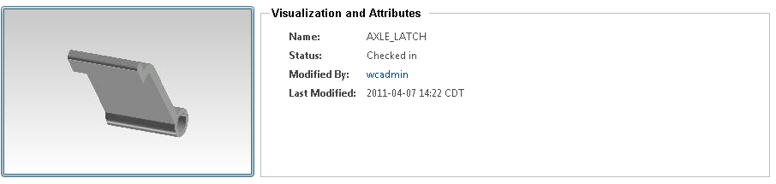

The component builder id for this builder is “visualizationAndAttributes” (ComponentId.VIZ_AND_ATTRIBUTES).
See the javadoc for VisualizationAttributesBuilder for more information.
To include this panel in your page you only need to specify the component builder id in the panel action or URL. See How to Find an Attribute Name/Id for more information on how to include panels in a JSP page.
If you have created a new Windchill type for which you would like to define a unique Visualization and Attributes panel, you will typically only need to define a layout for the INFO screen type in the Type and Attribute Management utility and possibly create a visualization delegate to display the visualization component.
In the rare cases where you need to modify some aspect of the panel, such as the view JSP, you should create a custom builder extending the VisualizationAttributesBuilder. You might want to modify the view JSP to include additional components or javascript on the page. See Customizing Information Page Components for more information.

Solution – Create an Advanced Attribute Panel Without a Visualization Component Using the Primary Attributes Layout

This is a panel identical to that described the previous section, but with no visualization component. It is created using the builder class PrimaryAttributesBuilder. The component builder id for this panel is “primaryAttributes” (ComponentId.PRIMARY_ATTRIBUTES).
This builder is invoked by the “primaryAttributes” action defined for the type “object.” This action is used to display the “Attributes” component on object information pages for types that do not have a visualization component:
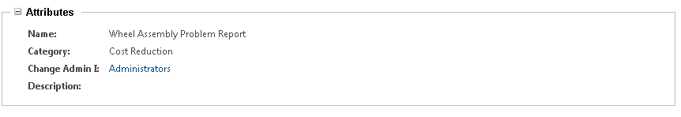
See the javadoc for PrimaryAttributesBuilder for more information.
To include this panel in your page you only need to specify the component builder id in the panel action or URL. See How to Find an Attribute Name/Id for more information on how to include panels in a JSP page.

Solution – Create an Advanced Attribute Panel Using the Create, Edit, or More Attributes Screen Type Layout

The system provides the builder TypedAttributesPanelBuilder:
• Information Page – More Attributes (ScreenDefinitionName.MORE_ATTRIBUTES)
• Create New (ScreenDefinitionName.CREATE)
• Edit (ScreenDefinitionName.UPDATE)

For a few objects the system has defined subclassesof PrimaryAttributesBuilder for the default builder.

This builder has the component builder id “attributesTable” (ComponentId.ATTRIBUTES_ID) and is used for the following actions defined for object type “object”:
• “attributes”
The action typically used to display the component typically labeled “More Attributes” on object information pages
• “defineItemAttributesWizStep”
Action which uses this builder indirectly to create the “Attributes” panel in object creation wizards. See Customizing Reusable Wizard Steps for more information.

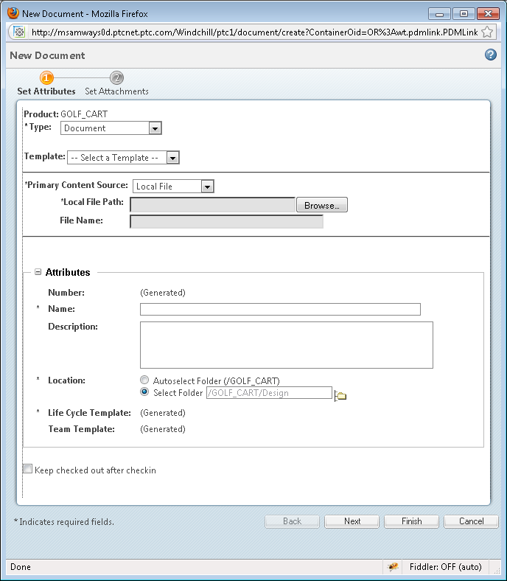

• “editAttributesWizStep”
Action which uses this builder indirectly to create the “Attributes” panel in object edit wizards. See Customizing Reusable Wizard Steps for more information.
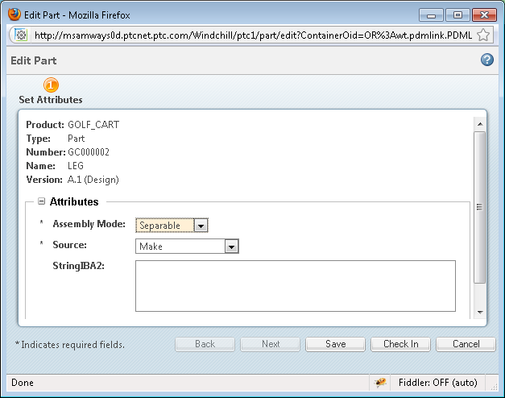

See the javadoc for TypedAttributesPanelBuilder for more information on the ComponentMode, ComponentType, view JSP, and datum object used for these panels. Note that the wizard panels have a ComponentType of ComponentType.WIZARD_ATTRIBUTES_TABLE so that the editable fields will be given HTML names such that the wizard processing framework can identify the attributes that it should automatically set on the object being created or edited. See Building Wizards to Create a Single Object for more information.
To include the “More Attributes” panel in your page you only need to specify the component builder id in the panel action or URL See How to Find an Attribute Name/Id for more information on how to include panels in a JSP page. To include the wizard panels in a wizard, use the common wizard step actions shown above.
If you have created a new Windchill type for which you would like to display one of these panels, you will typically only need to define a layout for the appropriate screen type in the Type and Attribute Management utility. In the rare cases where you need to modify some aspect of the panel, such as the view JSP, you should create a custom builder extending the TypedAttributesPanelBuilder. See Customizing Information Page Components for more information.
To modify the attributes displayed in these panels and their display properties you can modify the layout in the Type and Attribute Management utility. If it is necessary to modify a configuration property or the view JSP for a special use case, you can extend TypedAttributesPanelBuilder and override the buildAttributeComponentConfig() method (seeSolution – Create an Advanced Attribute Panel Using Any Layout Defined in the Type and Attribute Management Utility ). However, this should be avoided if at all possible as it will make the product less consistent.
The following configuration properties are not overridable:
• ComponentMode of the panel
• ComponentType of the panel
• Datum object
If you want to modify any of these elements, you should write a custom builder extending AbstractComponentBuilder. See Solution – Create an Advanced Attribute Panel Using Any Layout Defined in the Type and Attribute Management Utility for more information.

Solution – Create an Advanced Attribute Panel Using Any Layout Defined in the Type and Attribute Management Utility
Create an advanced attribute panel using a layout defined in the Type and Attribute Management utility. Attributes may be editable, view-only, or a combination of editable and view-only.
1. The attributes of the object type and their display properties are defined in the Type and Attribute Management utility and in the Java class file for the type.
2. The layout and content of the attribute panel are defined in the Type and Attribute Management utility.
3. A MVC Java builder class builds the panel configuration from the layout definition using the TypedAttrLayOutFactory. It also retrieves/creates the datum object for the panel.
4. GUI components for the attributes are created by data utilities.
5. The attributes and their data are rendered in a view JSP by the rendering framework using the configuration and data model created by the builder and the data utilities.
See Advanced Panel with Modified Context Object for an example of this solution.

Procedure – Creating the Attribute Panel
Either the builder com.ptc.jca.mvc.buildersTypedAttributesPanelBuilder or the builder com.ptc.mvc.components.AbstractComponentBuilder can be extended for creating a panel that is layout-based. If want to use the ComponentMode, ComponentType, and datum object set by the TypedAttributesPanelBuilder (refer to Solution – Create an Advanced Attribute Panel Using the Create, Edit, or More Attributes Screen Type Layout above) , you can extend the TypedAttributesPanelBuilder for convenience. Otherwise, you should extend the AbstractComponentBuilder.

Solution – Create a Simple or Advanced Attribute Panel Using a Configuration Created in a Java Builder Class

